Research Article

Aversive Ableism: Modern Prejudice Towards Disabled People
Carli Friedman, PhD
Council on Quality and Leadership
Abstract: The aim of this study was to examine the patterns of explicit (conscious) and implicit (unconscious) disability prejudice. The majority of participants were implicitly prejudiced against disabled people despite having low explicit prejudice. This pattern is in alignment with aversive ableism — disability prejudice was present among those who meant well.
Keywords: aversive ableism; prejudice; ableism
Unlike the historically prominent medical model of disability that frames disability as an individualized problem one “suffers” from and needs treatment for (Linton, 1998), the ideological shift to the social model conceptualizes disability as something that is socially constructed—a form of social oppression. Under this model, Barnes and Mercer (2003) “conceptualize disability as a form of social oppression akin to sexism and racism, although it exhibits a distinctive form, with its own dynamics…as a historically and culturally specific form of social oppression” (p. 18). Abberley (1987) also argues that the social model or social theory of disability is strongest when it is based on the concept of oppression. Abberley discusses oppression as socially created disadvantages that are placed upon disabled people. This includes the recognition of the social origins of impairment, and opposition to the economic, social, environmental, and psychological disadvantages imposed on disabled people.
Systemic discrimination, which is rooted in history, constitutes a significant amount of the oppression disabled people face. Barnes (1997) suggests, “To appreciate fully the extent and significance of the oppression of disabled people an understanding of history and its relationship to western culture: the central value system around which western society is clustered, is vital” (p. 4). According to Barnes, one of the important tenets of ancient Greek and Roman society was citizenship. The creation of the civilized man justified oppression because the creation of this category (civilized) also created an opposite; it made others, such as disabled people, uncivilized and justified their unequal treatment as such (Barnes, 1997). In early Christian and Jewish culture impairments were viewed as God’s punishment for wrongdoing (Barnes, 1997). In the 16th century, plagues, poor harvests, and reduced church wealth pressured the State to intervene in poverty (Barnes, 1997). In doing so, the first poor laws created a distinction between deserving and undeserving poor. Industrialization, which began in the 18th century, brought a period of enlightenment that emphasized science and reason (Barnes, 1997). Barnes argues this is where disability in its current form emerged as a result of productivity, medicalization, and the creation of normality.
In more recent history, disabled people were first addressed as a class by United States policy that defined them as sickly, such as ugly laws or “unsightly beggar ordinances” (Schweik, 2009, p. 140). Developed out of fear, these policies suggested purpose was to prevent people from getting disease by making sure they did not gaze upon those who were “ugly;” they also served to keep disabled people out of sight (Schweik, 2009). Another example of disability discrimination is when disability was used to justify the oppression and unequal treatment of women and other social minority groups in America (Baynton, 2001). According to Baynton, in the past Black people were seen as a disabled race in terms of biology because they were thought to have weaker organs and “suffered” from conditions such as Drapetomania, which caused enslaved people to run away. Moreover, suffragettes argued, “They were not disabled…and therefore were not proper subjects for discrimination” in order to win the right to vote (Baynton, 2001, p. 34). The linking of Black people and women with disability revealed not only an attempt to portray these groups as weak but also served to reinforce stereotypes of disability as unfit and therefore deserving of “less than.”
Although these historical examples may seem like ignorant decisions of the past, disabled people still face pervasive discrimination. For example, about 50% of disabled people experience poverty (Fremstad, 2009). The unemployment rate for disabled people has never been below its pre-civil war rate of 70% in the United States (Russell, 2000). To this day, disabled people are still forcibly sterilized for eugenic reasons (Alexander & Gomez, 2017; Garland-Thomson, 2017; Tilley, Walmsleya, Earlea, & Atkinsona, 2012). [Similarly, women of color are still forcibly sterilized for eugenic motivations (Johnson, 2013; Krase, 2014; Nittle, 2017) that parallel Bayton’s (2001) discussion of a portrayal of a ‘disabled race’ above, indicating traditional forms of prejudice and discrimination are far from resolved.] These are just a few examples of how disabled people are commonly discriminated against on both individual and systemic levels. Indeed, ableism, which Linton (1998) defines as “discrimination in favor of the able-bodied,” including “the idea that a person’s abilities or characteristics are determined by disability or that disabled people as a group are inferior to nondisabled people” (p. 9), still occurs today, although perhaps less often in the form of extremely overt policies such as ugly laws. Instead, many disabled people face subtle discrimination which is embedded in structures and social systems (Chen, Ma, & Zhang, 2011; Doyle, 2002; Keller & Galgay, 2010; Proctor, 2011; Rojahn, Komelasky, & Man, 2008). Ableism manifests itself through institutional, systemic, and subtle discrimination, however research has tended to focused less on subtle and implicit (unconscious) prejudice – everyday prejudice (Harpur, 2011; Keller & Galgay, 2010; Linton, 1998; Thompson, Bryson, & de Castell, 2001). Fortunately, disability’s theoretical and policy designation as a social minority, analogous in some ways to race, allows for other theories about discrimination to be investigated for relevance to disability.

Social Psychology Research on Modern Racism
The field of social psychology has examined different forms of modern implicit racism at length. Beginning in the 1950s the field changed to view prejudice as a normative process thereby shifting the focus away from pathology. As a result, this wave of study saw prejudice as existing in a large majority of people rather than a small subset of the deviant population (Dovidio, 2001; Gamst, Liang, & Der-Karabetian, 2011). Doing so birthed major research theories on unintentional and subtle modern biases such as those examined by symbolic¹ racism and aversive racism theories.
Unlike old-fashioned racism that looked at overt and dominant prejudice, symbolic racists believe racial discrimination is no longer a serious problem, disadvantaged Black people are just unwilling to take responsibility for their lives, Black people are demanding too much too quickly and thus going beyond what is “fair,” and the special treatment of Black people is not justified (Henry & Sears, 2002; McConahay & Hough, 1976; Sears & Henry, 2003, 2005; Sears, Henry, & Kosterman, 2000). Symbolic racism is rooted in abstract beliefs about socialized values, which Black people supposedly violate (Henry & Sears, 2002, 2008; McConahay & Hough, 1976; Sears et al., 2000). In order to be subtle and not overt, symbolic racism is typically expressed through symbols such as opposition to busing for integration. Symbolic racism is related to racial antipathy and conservative values, especially because “it is based on the belief that Blacks violate key American values, particularly the idea of individualism, the belief in working hard to get ahead in life” (Henry & Sears, 2008, p. 111). As a result, it is not uncommon for symbolic racism to influence political attitudes (Henry & Sears, 2008). However, symbolic racism operates separately with conservatism:
“General conservatism and traditional racial prejudice are psychologically separable and distinctive, but symbolic racism is grounded about equally in both. That is, symbolic racism is the glue that links political conservatism to racial prejudice” (Sears & Henry, 2003, p. 264).
Unlike symbolic racism that looks at subtle discrimination that exists among conservatives, aversive racism theory specifically focuses on those people who are progressive and well-meaning yet still participate in biased actions or thought (Dovidio, Pagotto, & Hebl, 2011; Gaertner & Dovidio, 1986; Gaertner, Dovidio, Nier, & Hodson, 2005). Aversive racists are those who believe they are not prejudiced—in fact, egalitarian values are important to their self-image—yet feel discomfort around Black people. When situations are not ambiguous and norms for behavior are well defined they will not participate in prejudiced acts or hold prejudiced beliefs; in fact, they may go out of their way to appear non-prejudiced in these situations (Dovidio & Gaertner, 2008; Gaertner & Dovidio, 1986, 2005). However, aversive racists act in prejudiced ways in ambiguous situations where it is harder to be “caught” being racist (Dovidio & Gaertner, 2008; Gaertner & Dovidio, 1986, 2005; Gaertner et al., 2005; Murrell et al., 1994). Thus, this form of racism theory examines aversive racists’ anxiety and discomfort around Black people, how this prejudice is inconsistent with their self-concepts, and the rationalized disassociated products of these inconsistencies.

Modern Disability Prejudice
Mainstream narratives portray disabled people in many harmful ways. For example, disabled people are commonly portrayed as pitiful, helpless, and bitter. These portrayals stress that disability is inherently negative and problematic and accordingly assumes disabled people are incapable and resentful. These portrayals of disability also inform nondisabled people’s attitudes towards disabled people. Although they may hold these problematic and negative views about disability, nondisabled people often simultaneously associate positive socially desirable traits to disabled people. These positively held beliefs are problematic not only because they create unfair expectations but also because they tend to impact how nondisabled people interact with disabled people. Thus, disability is located at an intersection unique to most social minority groups in that disabled people are both viewed negatively and often treated with particular care. These layers of attitudes are why it is particularly important to examine the complexities of disability attitudes and ableism.
Disability attitudes may appear positive thus making disability prejudice more hidden in its modern form. As disability prejudice can be confusing because it is almost always exclusively implicit rather than explicit (conscious), aversive racism theory may be a great window to examine it. I theorize that nondisabled people’s interaction with disabled people is more likely to be prejudiced in an aversive rather than symbolic fashion because social norms dictate it is not acceptable to discriminate (at least overtly) against disabled people – people would look ‘bad’ doing so. Social norms also dictate helping those in inferior and pitiable positions; people see disabled people as more deserving of help and positive treatment (Appelbaum, 2001; Garthwaite, 2011; Imrie & Wells, 1993; Stewart, Harris, & Sapey, 1999). Thus, the aim of this study was to establish a construct of aversive ableism by examining the patterns of explicit and implicit disability prejudice. To do so, this study operated under the following hypothesis: the majority of participants will be prejudiced in the aversive ableism pattern. This hypothesis was examined by comparing scores of participants on the explicit Symbolic Ableism Scale (SAS) and the Disability Attitudes Implicit Association Test (DA-IAT). A regression of explicit and implicit prejudice was conducted with linear, quadratic, and cubic components in order to explore the best-fit form of the relationship. Then, participants’ scores were categorized into prejudice styles using an adapted version of Son Hing, Chung-Yan, Hamilton, and Zanna’s (2008) two-dimensional model of prejudice.

Methods

Participants
Since it was expected that disability prejudice most commonly operates implicitly, different groups of participants were used to maximize the presence of different types of implicit prejudice. That is, to try to get the widest range of implicit prejudice instead of those who are all very prejudiced. Participants were graduate and undergraduate students recruited through a large diverse urban university. Graduate students were working towards a doctorate or master’s degree in a disability related field, while the undergraduate students came from a wide variety of disciplines across the university but were taking an undergraduate level course related to disability. It was theorized that these participant groups would produce a spectrum of implicit prejudice because of their varying relationships with disability. It was expected that the graduate students would serve as the ‘low norm’ as they would have lower implicit levels of prejudice or favor disabled people because of their interaction with disability studies and the disability community. Students in undergraduate level classes self-selected to take disability courses so it was expected they would have somewhat less implicit prejudice than the general population but it is likely they still have implicit prejudice because they are less likely to have the depth of understanding of disability studies graduate students.
To determine the minimum necessary sample size, an a priori G*Power analysis was completed using G*Power 3.1 (Erdfelder, Faul, & Buchner, 1996; Faul, Erdfelder, Buchner, & Lang, 2009; Faul, Erdfelder, Lang, & Buchner, 2007). As the aim was to have large variation in D scores (DA-IAT), for the G*Power calculation the group means used were from -.65 to .65; M = 0, SD = .44; power (1 - β) = .95; α = .05. The analysis indicated that a total sample of 35 people would be needed for the large effect size (η² = .93). To strengthen the research, the goal was to have about 100 people complete the study. However, size was dependent on who volunteered for the study, thus we had 84 participants. Participant demographics can be seen in Table 1.

Table 1: Demographic of Sample
Demographics of Sample
Characteristic |  | n | %
Gender
 | Woman | 71 | 84.5
 | Man | 12 | 14.3
 | Neither | 1 | 1.2
Age range
 | 18-25 | 66 | 78.6
 | 26-33 | 14 | 16.7
 | 34-40 | 2 | 2.4
 | 41-48 | 1 | 1.2
 | 49-56 | 1 | 1.2
Disability
 | No | 67 | 79.8
 | Yes | 14 | 16.7
 | Prefer not to say | 3 | 3.6
Race
 | White | 32 | 38.1
 | Asian or Pacific islander | 22 | 26.2
 | Hispanic or Latino/a | 16 | 19
 | Black | 6 | 7.1
 | Middle Eastern | 4 | 4.8
 | Interracial | 3 | 3.6
 | Other | 1 | 1.2
Education level
 | Undergraduate | 68 | 81.0
 | Graduate | 16 | 19.0
Political orientation
 | Liberal | 48 | 57.1
 | Conservative | 8 | 9.5
 | Other | 28 | 33.3

Instruments

Disability Attitudes Implicit Association Test
One of the most prominent implicit methods is the Implicit Associations Test (IAT), a projective method (Greenwald, McGee, & Schwartz, 1998). The IAT presents participants with two target-concept discriminations (e.g., Black and White) and two attribute dimensions (e.g., pleasant and unpleasant). Participants must categorize stimuli as belonging to the categories in different stereotype congruent and incongruent combinations. By measuring reaction time the IAT is able to examine associations – the quicker the reaction time, the stronger the association between groups and traits (Karpinski & Hilton, 2001).
The DA-IAT (Greenwald et al., 1998) is the most prominent disability related IAT. The DA-IAT is similar to the standard IAT, except it uses symbols to represent ‘disabled-persons’ and ‘abled-persons’ target-concept discriminations and word stimuli for ‘good’ and ‘bad’ attribute dimensions. For example, the wheelchair symbol represents disabled people while someone skiing represents a nondisabled person. Several studies have shown the DA-IAT’s construct validity (Aaberg, 2012; Pruett, 2004; Pruett & Chan, 2006), discriminant validity (White et al., 2006), and reliability (Pruett, 2004; Pruett & Chan, 2006; Thomas et al., 2014). Moreover, research has shown that even when participants try to fake an IAT, faking is evident (Cvencek et al., 2010). The IAT has built in safeguards against participants selecting at random or trying to fake. The updated scoring algorithm includes eliminating any trials with response latencies of greater than 10,000 milliseconds (Greenwald et al., 2003). Moreover, any subjects who have 10% or more trials less than 300 milliseconds will be removed (Greenwald et al., 2003).

Symbolic Ableism Scale
The Symbolic Ableism Scale (SAS) (Friedman & Awsumb, in press) was used to measure participants’ explicit bias. The SAS presents participants with thirteen statements about disability on a seven-point Likert scale (from strongly disagree to strongly agree). For example, one item is: “disabled people are demanding too much from the rest of society.” The SAS has been found to have good construct validity (Friedman & Awsumb, in press).

Procedure
After approval from the university’s Institutional Review Board, this study was administered to participants on a unique website. After being presented with the informed consent, participants received instructions about the DA-IAT; they were told to push the ‘E’ key if the stimuli belonged in the categories listed on the left and the ‘I’ on the right. They were told to do this as quickly as possible but with the least amount of errors. If participants placed stimuli to the wrong side a red X appeared in the middle of the screen until they made the correct choice.
The DA-IAT involves seven blocks (rounds) of categorization tasks. In the first DA-IAT practice block the screen shows only the target-concept discriminations with ‘abled-persons’ on the left of the screen and ‘disabled persons’ on the right. Participants were presented with 20 trials of randomized disabled and abled-persons stimuli in the middle of the screen and were asked to sort them accordingly. The second practice block is similar; ‘good’ is on the left of the screen and ‘bad’ is on the right and participants sort the related good and bad stimuli for 20 trials. For block three both ‘abled-persons’ and ‘good’ are on the left and ‘disabled persons’ and ‘bad’ are on the right. They were then presented with all the stimuli options for 20 trials. Block four is exactly the same except it lasts for 40 trials. Block five, which lasts 40 trials, is also a practice block where only ‘bad’ is listed on the left and ‘good’ on the right and they were only presented with good and bad stimuli. This gives participants the opportunity to get used to the switched location of these two attribute dimensions. Block six begins the stereotype inconsistent items. For both block six and seven ‘disabled persons’ and ‘good’ are on the left and ‘abled-persons’ and ‘bad’ are on the right. They are presented with all of the stimuli again. Block six includes 20 trials while block seven includes 40. Participants were randomized to receive either this order of blocks or stereotype inconsistent items in block three and four (disabled persons and good and abled-persons and bad) and then consistent in blocks six and seven (disabled persons and bad and abled-persons and good).
After completing the DA-IAT, participants completed the SAS. The IAT was administered before the SAS to avoid any possible priming. Finally, participants answered questions about their demographics.

Analysis
SPSS 21 was used for all analysis. The implicit D scores from the DA-IAT were analyzed using the updated IAT scoring procedure (Greenwald et al., 2003). D scores were produced for each participant based on their response latencies in stereotype consistent and stereotype inconsistent blocks. Scores of implicit prejudice (DA-IAT) reported the strength of preference for nondisabled or disabled people. D scores larger than .14 reveal a preference for nondisabled people over disabled ones (Aaberg, 2012; Greenwald et al., 2003). Scores of .15 to .34 reveal a slight preference for nondisabled people, .35 to .64 a moderate preference, and .65 and greater a strong preference (Aaberg, 2012; Greenwald et al., 2003). Negative values of the same values above reveal preferences for disabled people, and scores from -.14 to .14 reveal no prejudice (Aaberg, 2012; Greenwald et al., 2003).
Explicit measures of the symbolic ableism seven-point Likert scale were first reverse scored when applicable and then recoded from one to seven to zero to one in accordance with the SAS. An explicit disability prejudice SAS score was calculated for each participant using the mean score of these Likert items.
The relationship between implicit and explicit prejudice was examined using linear, quadratic, and cubic regressions to determine the best-fit form of the relationship. Then, in order to determine types of prejudice present in alignment with Son Hing et al.’s (2008) two-dimensional model of prejudice participants’ explicit and implicit scores were categorized as high and low. There are no standardized cut-offs for high and low for explicit and implicit prejudice levels; Son Hing et al. (2008) comment, “a potential problem with this approach [of classifying as explicit and implicit scores as high and low] is that cut-off scores are sample specific and malleable” (p. 983). For this reason, implicit scores were cut-off based on the moderate prejudice level (.35) according to IAT standards. The SAS cut-off used was the mid-point equivalent on the Likert scale (.50). After the explicit and implicit scores were categorized as high and low, profiles from Son Hing et al.’s (2008) two-dimensional model of prejudice were used to categorize types of prejudice: high explicit and high implicit are symbolic prejudiced; high explicit and low implicit are principled conservatives²; low explicit and high implicit are aversive prejudiced; and, low explicit and low implicit are truly low prejudiced.

Results
The mean of all participants’ (n = 84) explicit scores was .31 (SD = .13) (moderate explicit prejudice). Figure 1 details the density and distribution of the explicit prejudice results. The results on the Shapiro-Wilk’s test were not significant suggesting the scores were normally distributed.
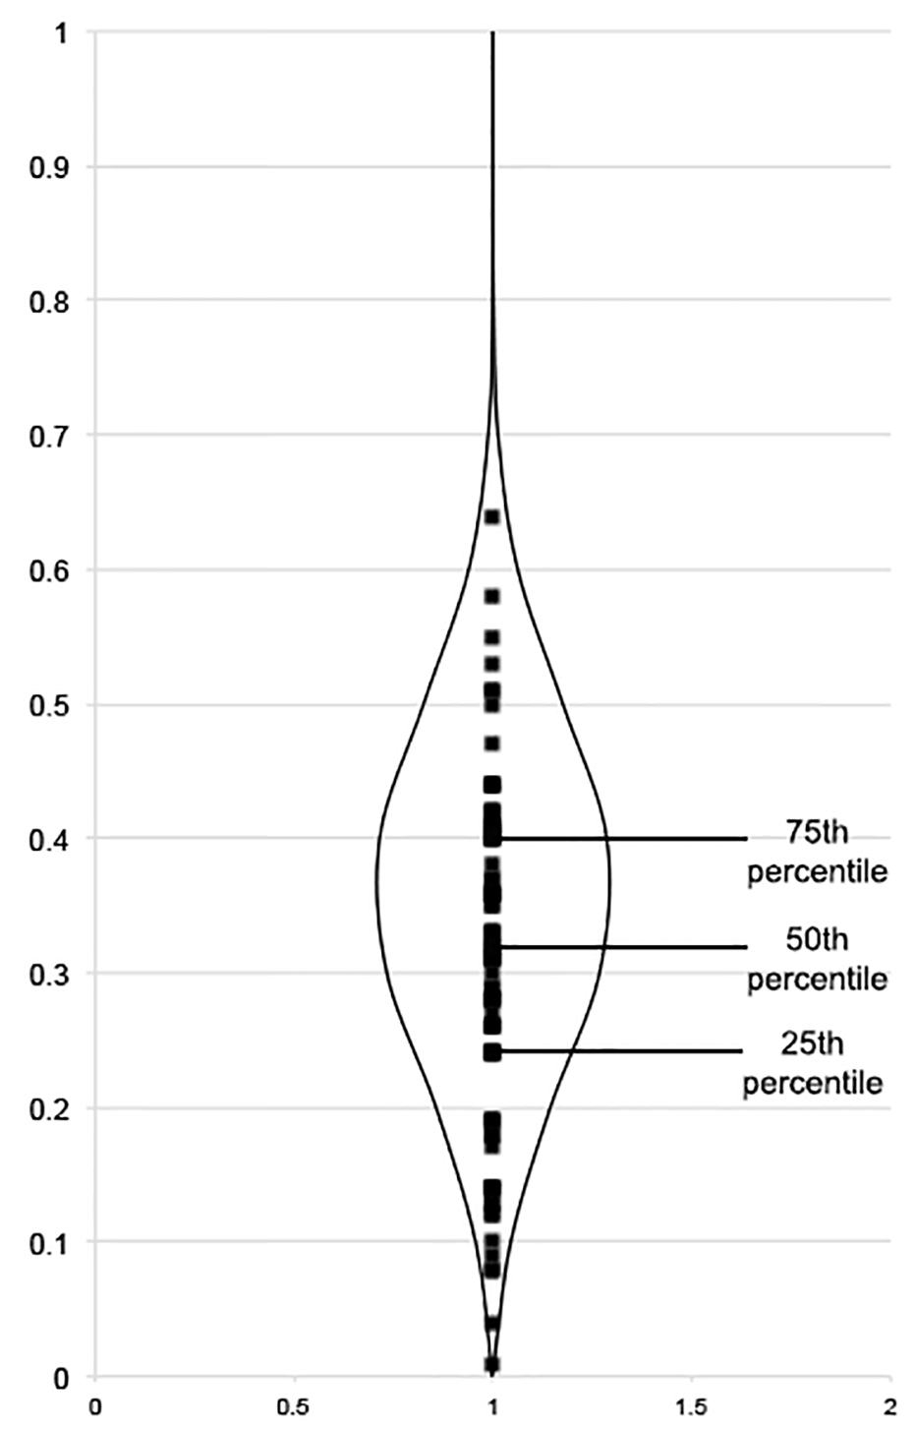
Figure 1. Beanplot of explicit prejudice. The beanplot’s shape details explicit prejudice’s density while the beans mark the distribution of scores. The beanplot indicates most people scored within .2 and .4 on the SAS.
On the DA-IAT, the participants had a mean D score of .45 (SD = .44) (moderate preference for nondisabled people). This score was significantly different from zero according to a one-tailed t-test (t(81) = 9.28, p < .001), indicating an implicit preference for nondisabled people. In this study 79.3% (n = 65) of participants preferred nondisabled people, 9.8% (n = 8) preferred disabled people, and 11% (n = 9) had no preference. The majority of participants strongly preferred nondisabled people; see Figure 2 for the distribution of scores. It should be noted two participants’ D scores were excluded from the analysis. One participant’s D score was excluded because it was an extreme outlier that affected the normality and caused a failed Shapiro-Wilk test. The other participant’s D score was excluded because of an error rate greater than 30%³, suggesting they were not following instructions or did not understand the task.
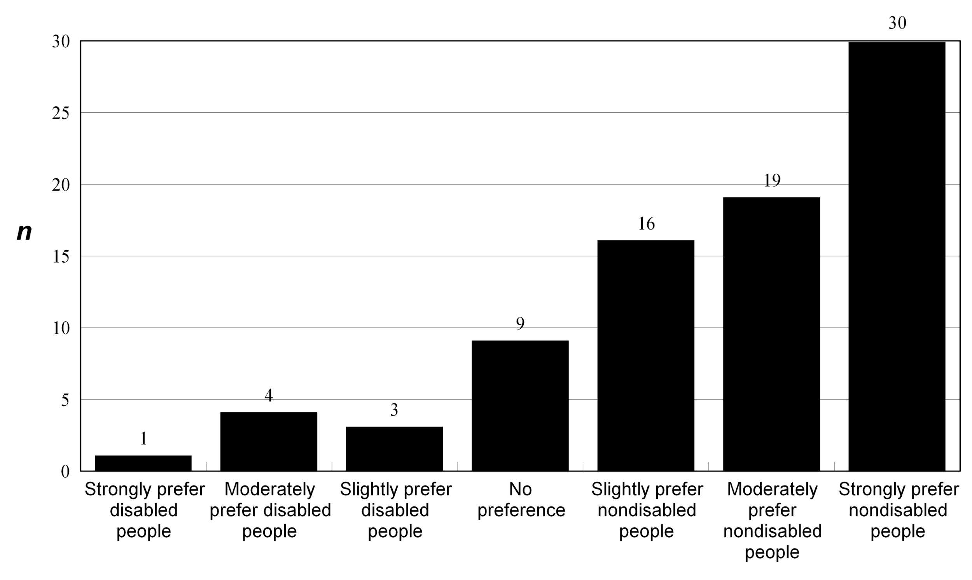
Figure 2. Implicit preferences for nondisabled and disabled people. The figure indicates the majority of people preferred nondisabled people, with fewer people scoring as having no preference, or preferring disabled people.
A centered regression analysis was conducted to evaluate the relationship between explicit and implicit scores and the prediction of the implicit scores from the explicit scores. The variables have a quadratic relationship, which was significant F(2, 79) = 5.31, p = .007. The regression equation for predicting the implicit scores from the explicit scores is
Implicit Score = .52 + .98(Explicit Score – .31) – 4.41(Explicit Score – .31)²
For example, according to the model, a person with an explicit score of 0 would be expected to have an implicit score of -.21 (slightly prefer disabled people), an explicit score of .25 would indicate an implicit score of .45 (moderately prefer nondisabled people), and an explicit score of .50 would suggest an implicit score of .55 (moderately prefer nondisabled people). Both the explicit mean deviation score and the quadratic term were significant at t = 2.46, p = .016 and t = -2.00, p = .049 respectively. Although statistically significant, this model only predicts 12% of the implicit scores so it is still a fairly weak relationship.
In order to determine types of prejudice present in alignment with an adapted version of Son Hing et al.’s (2008) two-dimensional model of prejudice participants’ explicit and implicit scores were categorized as high and low. Using these criteria participants’ scores were then grouped into symbolic ableist (high explicit, high implicit), principled conservatives (high explicit, low implicit), aversive ableist (low explicit, high implicit), and truly low prejudiced (low explicit, low implicit). Participants were classified as 5 symbolic ableists, 44 aversive ableists, 2 principled conservatives, and 31 truly lowly prejudiced (Figure 3).

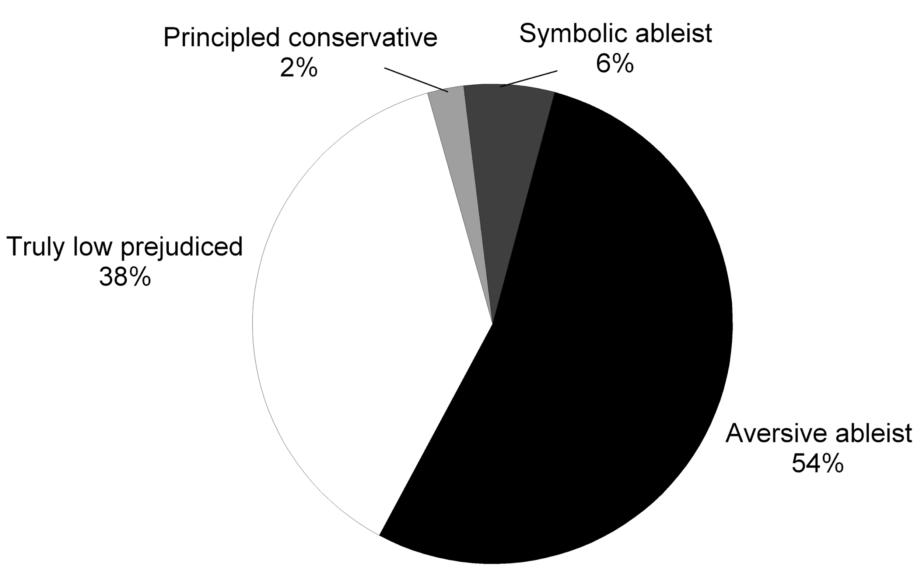
Figure 3. Styles of prejudice (n = 82). This figure shows the breakdown of participants’ ableism types; the majority of participants fell into the aversive ableist category with fewer truly low prejudiced, symbolic ableist, or principled conservative.

Discussion
Reconceptualizing ableism in a less dichotomous nature can help us reframe ableism to better capture, and in the future change, the complexities of everyday unconscious microaggressions that are so detrimental to disabled people. In order to help complicate current understandings of ableism – to interrupt a dichotomous understanding of ableism in which one is prejudiced or not – this study established the construct of aversive ableism by examined the patterns of explicit and implicit prejudice using an adapted version of Son Hing et al.’s (2008) two-dimensional model of prejudice. Doing so was a necessary first step so that the intricacies of these complex and multidimensional forms of prejudice can be mapped and, ultimately, reduced.
It was theorized that nondisabled people’s interaction with disabled people is more likely to be prejudiced in an aversive (low explicit, high implicit) rather than symbolic fashion (high explicit, high implicit) because social norms dictate it is not acceptable to discriminate (at least overtly) against disabled people. In alignment with the study’s hypothesis, findings revealed although explicit scores were fairly low, suggesting people consciously held (or recognized holding) little prejudice, the majority of the participants preferred nondisabled people implicitly, indicating they were indeed prejudiced. This pattern is in alignment with aversive ableism. Using this model, the majority of participants were aversive ableists (54% aversive ableists, 38% truly low prejudiced, 6% symbolic ableists, and 2% principled conservative). Our findings indicate many people are more prejudiced against disabled people than they understand or recognize; in fact, our findings suggest that this may be the most common type of modern prejudice – those who feel positively but hold negative attitudes about disabled people.
Now that the two-dimensional concept of aversive ableism has been documented, all aspects of how this prejudice operates must be understood. A necessary next step to build upon and map this concept is for research to now explore the differentiations between aversive ableism and aversive racism. The subtle experiences of discrimination disabled people face are particular to them because of both their unique history and their present-day experiences as a discriminated against social minority. On the basis of common disability narratives and stereotypes, there will be some differences between aversive racism and aversive ableism both in context and expression; aversive racism cannot just be “applied” to disability. These disability narratives are not only harmful but also differentiate disabled people from other social minority groups. For example, the inspiration narrative that dictates that everything disabled people do is inspirational because they must ‘overcome’ their disability is harmful for disabled people because it implies either that they are not normal or that they achieve monumental tasks ‘despite’ their disability. Not only does this not reflect the lived reality of most people, it also creates unattainable expectations for disabled people by perpetuating the myth that their true disability is a bad attitude instead of institutional barriers (Tighe, 2001). Another disability narrative that most likely interacts with aversive ableism is pity. Although having pity for someone is not inherently negative, the pity narrative is harmful for disabled people because it assumes that they are inherently tragic because of their disabilities, that they are incapable, or that they are victims (Reid, Stoughton, & Smith, 2006). These factors, among others, separate disabled people and the discrimination they face from other social minorities. For this reason, their experiences will be unique. Aversive ableism is not likely just to be aversive racism by another name applied to another group; rather, it likely builds on an understanding of prejudice often too subtle to articulate in rapid social interaction but which affects the group immensely. These layers of attitudes are why it is particularly important to examine nondisabled peoples’ explicit and implicit attitudes about disability, especially how they may differ from similar forms of racism. Aversive racism has useful lessons for disability; however, it also raises many points of difference between race and disability that suggest a need for a unique concept of aversive ableism that is ultimately unique from aversive racism.
This study’s evidence of aversive ableism is one of the first steps in developing the construct of aversive ableism. However, aversive ableism, like aversive racism, is a complex concept that is beyond the scope of just one study. Future research can “examine prejudice as it relates to unambiguously meaningful behaviors and among relevant populations… to make progress in this debate” (Payne, Krosnick, Pasek, Lelkes, Akhtar, & Tompson, 2010, p. 368; von Hippel, Brener, & von Hippel, 2008). This includes examining how it may differ from aversive racism theory as suggested above but also future aversive ableism studies could benefit from expanding to larger groups of participants from wider backgrounds. For example, one possibility for future study of aversive ableism is to focus on different groups such as direct support professionals or families of disabled people that interact with disabled people yet may hold aversive attitudes.
Another avenue for the future to explore is the relationship between political orientation and symbolic and aversive ableism. The differentiation between conservatives and liberals’ disability prejudice may be less clear-cut than with racism because of complex attitudes towards disabled people and social norms that portray disabled people as deserving of positive and favorable treatment. Conservative ‘pull yourself up by your bootstrap’ individualism and dislike for welfare systems may certainly interfere with their views of disabled people; however:
“Unlike the experience of many minorities, opposition to disability rights seldom has been marked by overt displays of bigotry or hostility; and politicians have often been included to provide sympathetic endorsements for the goals of disabled persons, even when they have shown strong resistance to the claims of other disadvantaged groups” (Hahn, 2005, p. 42).
Moreover, as Berdein (2007) found principles are not consistent across people, and some conservatives apply and abandon their principles differently depending on race, the differentiation between principled conservatism and symbolic ableism needs to be explored more in depth.
Although this study has uncovered many aspects of aversive ableism, it is not without its limitations. One major limitation of this study was related to the subject pool. Because of financial restrictions this study’s participants were all students. Although there is a precedent for using university students as participants, especially in social sciences research, students are young and more often from middle class backgrounds (Peterson, 2001; Peterson & Merunka, 2014; Walpole, 2003). Despite recruitment occurring at a very diverse urban university, it is possible the results would be different if it had been possible to have random subjects from the general population. Similarly, although the study aimed for an even gender breakdown, the majority of participants were women. This may have implications as women in Hirschberger, Florian, & Mikulincer’s (2005) study had more favorable attitudes towards disabled people than men. This study took place in an university environment; it is possible aversive ableism is enacted differently in these settings than in the real world. This subject pool is also limited by the volunteer basis of its participants. There is a chance of self-selection bias as a result. Similarly, another limitation of this study was that participants were more educated about disability than the general population. This is tied to a potential selection bias because all participants are in disability related courses. It is likely that the general population of disabled people would have more implicit prejudice (Nosek, Smyth, Hansen, Devos, Lindner, Ranganath, & Banaji, 2007) and therefore significantly less people would fall into the ‘truly low prejudice category.’
Once research has shown a more in depth understanding of aversive ableism, work can begin to reduce this subtle yet common form of disability prejudice. Aversive forms of prejudice are not so easily reduced because people already believe they are being egalitarian – they are not motivated to change because they do not realize they are prejudiced (Gaertner & Dovidio, 1986, 2005). Gaertner et al. (2005) explains, “Like a virus that has mutated, racism may have evolved into different forms that are more difficult not only to recognize but also to combat” (p. 385). While its inevitability is often assumed, the social devaluation of disabled people is not inevitable and can be reduced, although not easily (Gill, 2000; Susman, 1994). Although according to literature on aversive racism simply telling people they are prejudiced is not an effective intervention, in terms of reducing aversive racism, the most prominent intervention is the common ingroup identity model, which in recognizing the role of social categorization, uses the positive consequences of ingroup membership and recategorization instead of trying to reduce the negatives of outgroup membership (Dovidio & Gaertner, 2004; Dovidio, Gaertner, Anastasio, & Sanitioso, 1992; Gaertner & Dovidio, 2005; Murrell et al., 1994). Future research should examine if the common ingroup identity model is also a useful intervention to reduce aversive ableism. In the meantime, at the very least, it may be more fruitful for people to critically examine ones’ own privileges and prejudices than to do nothing. Certainly, no harm is going to come from figuring out how one is committing microaggressions and consciously trying to change ones’ behavior.
Many participants in this study believed they viewed disabled people positively. Yet, the types of discrimination and prejudice that have been evidenced for so long in literature were still present among people who meant well. This pattern of prejudice – aversive ableism – may be one of the most prominent forms of ableism today. In order to combat it, we must first understand it. This study took one of the first steps by establishing aversive ableism as a two-dimensional construct, and reconceptualizing ableism as a spectrum. Next, the hard work of disrupting these unconscious processes can begin. Doing so is necessary to end the social oppression of disabled people.
Carli Friedman, PhD. is the Director of Research at The Council on Quality and Leadership (CQL). She received her PhD in Disability Studies from the University of Illinois of Chicago. Her research focuses on ableism, meaningful community inclusion, and quality of life.

References
Aaberg, V. A. (2012). A path to greater inclusivity through understanding implicit attitudes toward disability. The Journal of Nursing Education, 51(9), 505-510. doi:10.3928/01484834-20120706-02
Abberley, P. (1987). The concept of oppression and the development of a social theory of disability. Disability, Handicap & Society, 2(1), 5-19. doi:10.1080/02674648766780021
Alexander, N., & Taylor Gomez, M. (2017). Pleasure, sex, prohibition, intellectual disability and dangerous ideas. Reproductive Health Matters, 25(50), 114-120, doi: 10.1080/09688080.2017.1331690
Appelbaum, L. D. (2001). The influence of perceived deservingness on policy decisions regarding aid to the poor. Political Psychology, 22(3), 419-442. doi:10.2307/3792421
Barnes, C. (1997). A legacy of oppression: A history of disability in Western culture. In L. Baron & M. Oliver (Eds.), Disability studies: Past, present and future (pp. 3-24). Leeds: The Disability Press.
Baynton, D. C. (2001). Disability and the justification of inequality in American history. In P. Longmore & L. Umansky (Eds.), The new disability history: American perspectives (pp. 33-57). New York: University Press.
Berdein, I. (2007). Principled conservatives or covert racists: Disentangling racism and ideology through implicit measures (Doctoral dissertation). Stony Brook University, Stony Brook, NY.
Chen, S., Ma, L., & Zhang, J.-X. (2011). Chinese undergraduates’ explicit and implicit attitudes toward persons with disabilities. Rehabilitation Counseling Bulletin, 55(1), 38-45. doi:10.1177/0034355211410705
Cvencek, D., Greenwald, A. G., Brown, A. S., Gray, N. S., & Snowden, R. J. (2010). Faking of the implicit association test is statistically detectable and partly correctable. Basic & Applied Social Psychology, 32, 302-314. doi:10.1080/01973533.2010.519236
Cvencek, D., Greenwald, A. G., & Meltzoff, A. N. (2011). Measuring implicit attitudes of 4-year-olds: The Preschool Implicit Association Test. Journal of Experimental Child Psychology, 109, 187-200. doi:10.1016/j.jecp.2010.11.002
Cvencek, D., Meltzoff, A. N., & Greenwald, A. G. (2011). Math–gender stereotypes in elementary school children. Child Development, 82(3), 766-779. doi:10.1111/j.1467-8624.2010.01529.x
Dionne, C. D., Gainforth, H. L., O’Malley, D. A., & Latimer-Cheung, A. E. (2013). Examining implicit attitudes towards exercisers with a physical disability. The Scientific World Journal, 2013. doi:10.1155/2013/621596
Dovidio, J. F. (2001). On the nature of contemporary prejudice: The third wave. Journal of Social Issues, 57(4), 829-849. doi:10.1111/0022-4537.00244
Dovidio, J. F., & Gaertner, S. L. (2004). Aversive racism. Advances in Experimental Social Psychology, 36(1), 1-52. doi:10.1016/S0065-2601(04)36001-6
Dovidio, J. F., & Gaertner, S. L. (2008). New directions in aversive racism research: Persistence and pervasiveness. In C. Willis-Esqueda (Ed.), Motivational aspects of prejudice and racism (pp. 43-67): Springer New York.
Dovidio, J. F., Gaertner, S. L., Anastasio, P. A., & Sanitioso, R. K. (1992). Cognitive and motivational bases of bias: Implications of aversive racism for attitudes toward Hispanics. In S. B. Knouse, P. Rosenfeld, & A. Culbertson (Eds.), Hispanics in the workplace (pp. 75-106). Newbury Park, California: Sage Publications.
Dovidio, J. F., Pagotto, L., & Hebl, M. R. (2011). Implicit attitudes and discrimination against people with physical disabilities. In R. L. Wiener & S. L. Willborn (Eds.), Disability and Aging Discrimination (pp. 157-183). New York: Springer.
Doyle, A. (2002). The viability of the implicit association test applied to attitudes toward individuals with disabilities and measurement of coworker attitudes toward individuals with a disability. (Master of Arts), Western Kentucky University, Bowling Green, Kentucky. Retrieved from http://digitalcommons.wku.edu/theses/654 (654)
Enea-Drapeau, C., Carlier, M., & Huguet, P. (2012). Tracking subtle stereotypes of children with trisomy 21: From facial-feature-based to implicit stereotyping. PloS one, 7(4), e34369. doi:10.1371/journal.pone.0034369
Erdfelder, E., Faul, F., & Buchner, A. (1996). GPOWER: A general power analysis program. Behavior Research Methods, Instruments, & Computers, 28(1), 1-11. doi:10.3758/BF03203630
Faul, F., Erdfelder, E., Buchner, A., & Lang, A.-G. (2009). Statistical power analyses using G* Power 3.1: Tests for correlation and regression analyses. Behavior research methods, 41(4), 1149-1160. doi:10.3758/BRM.41.4.1149
Faul, F., Erdfelder, E., Lang, A.-G., & Buchner, A. (2007). G* Power 3: A flexible statistical power analysis program for the social, behavioral, and biomedical sciences. Behavior research methods, 39(2), 175-191. doi:10.3758/BF03193146
Fremstad, S. (2009). Half in ten: Why taking disability into account is essential to reducing income poverty and expanding economic inclusion. Washington, DC: Center for Economic and Policy Research.
Friedman, C. & Awsumb, J. (in press). The Symbolic Ableism Scale. Review of Disability Studies: An International Journal.
Gaertner, S. L., & Dovidio, J. F. (1986). The aversive form of racism. In S. L. Gaertner & J. F. Dovidio (Eds.), Prejudice, discrimination, and racism: Theory and research (pp. 61-89). Orlando: Academic Press.
Gaertner, S. L., & Dovidio, J. F. (2005). Understanding and addressing contemporary racism: From aversive racism to the common ingroup identity model. Journal of Social Issues, 61(3), 615-639. doi:10.1111/j.1540-4560.2005.00424.x
Gaertner, S. L., Dovidio, J. F., Nier, J., & Hodson, G. (2005). Aversive racism: Bias without intention. In L. B. Nielsen & R. L. Nelson (Eds.), Handbook of employment discrimination research (pp. 377-395). Netherlands: Springer.
Gamst, G. C., Liang, C. T. H., & Der-Karabetian, A. (2011). Racism- and Prejudice-Related Measures Handbook of Multicultural Measures (pp. 251-335): SAGE Publications, Inc.
Garland-Thomson, R. (2017). Eugenic world building and disability: The strange world of Kazuo Ishiguro's Never Let Me Go. Journal of Medical Humanities, 38(2), 133-145. doi: 10.1007/s10912-015-9368-y
Garthwaite, K. (2011). ‘The language of shirkers and scroungers?’ Talking about illness, disability and coalition welfare reform. Disability & Society, 26(3), 369-372. doi:10.1080/09687599.2011.560420
Gill, C. (2000). Divided understandings: The social experience of disability. In G. L. Albrecht, K. D. Seelman, & M. Bury (Eds.), Handbook of Disability Studies (pp. 351-372). Thousand Oaks: Sage.
Greenwald, A. G., & Farnham, S. D. (2000). Using the implicit association test to measure self-esteem and self-concept. Journal of Personality and Social Psychology, 79(6), 1022-1038. doi:10.1037/0022-3514.79.6.1022
Greenwald, A. G., McGhee, D. E., & Schwartz, J. L. K. (1998). Measuring individual differences in implicit cognition: The implicit association test. Journal of Personality and Social Psychology, 74(6), 1464-1480. doi:10.1037/0022-3514.74.6.1464
Greenwald, A. G., Nosek, B. A., & Banaji, M. R. (2003). Understanding and using the Implicit Association Test: I. An improved scoring algorithm. Journal of Personality and Social Psychology, 85(2), 197-216. doi:10.1037/0022-3514.85.2.197
Hahn, H. (2005). Antidiscrimination laws and social research on disability: the minority group perspective. In P. Blanck (Ed.), Disability Rights (pp. 343-361). Burlington, VT: Ashgate.
Harpur, P. (2011). Embracing the new disability rights paradigm: The importance of the Convention on the Rights of Persons with Disabilities. Disability & Society, 27(1), 1-14. doi:10.1080/09687599.2012.631794
Harris, R. M., & Harris, A. C. (1977). Devaluation of the disabled in fund raising appeals. Rehabilitation Psychology, 24(2), 69-78. doi:10.1037/h0090915
Henry, P. J., & Sears, D. O. (2002). The Symbolic Racism 2000 Scale. Political Psychology, 23(2), 253-283. doi:10.1111/0162-895x.00281
Henry, P. J., & Sears, D. O. (2008). Symbolic and modern racism. In J. H. Moore (Ed.), Encyclopedia of race and racism (pp. 111-117). Farmington Hills, MI: Macmillan Reference.
Hirschberger, G., Florian, V., & Mikulincer, M. (2005). Fear and compassion: A terror management analysis of emotional reactions to physical disability. Rehabilitation Psychology, 50(3), 246-257. doi:10.1037/0090-5550.50.3.246
Huang, Y., Wang, L., & Shi, J. (2009). When do objects become more attractive? The individual and interactive effects of choice and ownership on object evaluation. Personality and Social Psychology Bulletin, 35(6), 713-722. doi:10.1177/0146167209333046
Ilavarasu, J. V., Rajesh, S. K., & Hankey, A. (2014). Implicit measure for yoga research: Yoga implicit association test. International journal of yoga, 7(2), 120. doi:10.4103/0973-6131.133889
Imrie, R. F., & Wells, P. (1993). Disablism, planning, and the built environment. Environment and Planning C, 11, 213-213. doi:10.1068/c110213
Johnson, C. G. (2013). Female inmates sterilized in California prisons without approval. Retrieved from https://www.revealnews.org/article-legacy/female-inmates-sterilized-in-california-prisons-without-approval/
Karpinski, A., & Hilton, J. L. (2001). Attitudes and the Implicit Association Test. Journal of Personality and Social Psychology, 81(5), 774-788. doi:10.1037/0022-3514.81.5.774
Karpinski, A., Steinman, R. B., & Hilton, J. L. (2005). Attitude importance as a moderator of the relationship between implicit and explicit attitude measures. Personality and Social Psychology Bulletin, 31(7), 949-962. doi:10.1177/0146167204273007
Keller, R. M., & Galgay, C. (2010). Microagressive experiences of people with disabilities. In D. W. Sue (Ed.), Microaggressions and marginality: Manifestation, dynamics and impact (pp. 241-267). Hoboken, NJ: John Wiley & Sons, Inc.
Krase, K. (2014). History of forced sterilization and current U.S. abuses. Retrieved from https://www.ourbodiesourselves.org/health-info/forced-sterilization/
Linton, S. (1998). Claiming disability, knowledge and identity. New York: New York University Press.
Ma, L., Chen, S., Zhou, M., & Zhang, J. (2012). Social axioms and implicit attitudes about people with disabilities. Social Behavior and Personality: an international journal, 40(2), 251-258. doi:10.2224/sbp.2012.40.2.251
Maison, D., Greenwald, A. G., & Bruin, R. (2001). The Implicit Association Test as a measure of implicit consumer attitudes. Polish Psychological Bulletin, 32(1), 61-69.
McConahay, J. B., & Hough, J. C. (1976). Symbolic Racism. Journal of Social Issues, 32(2), 23-45. doi:10.1111/j.1540-4560.1976.tb02493.x
Murrell, A. J., Dietz-Uhler, B. L., Dovidio, J. F., Gaertner, S. L., & Drout, C. (1994). Aversive racism and resistance to affirmative action: Perception of justice are not necessarily color blind. Basic and Applied Social Psychology, 15(1-2), 71-86. doi:10.1080/01973533.1994.9646073
Nittle, N. K. (2017). The U.S. government's role in sterilizing women of color. Retrieved from https://www.thoughtco.com/u-s-governments-role-sterilizing-women-of-color-2834600
Nosek, B. A., Banaji, M. R., & Greenwald, A. G. (2002). Harvesting implicit group attitudes and beliefs from a demonstration web site. Group Dynamics: Theory, Research, and Practice, 6(1), 101-115. doi:10.1037//1089-2699.6.1.101
Nosek, B. A., Smyth, F. L., Hansen, J. J., Devos, T., Lindner, N. M., Ranganath, K. A., . . . Banaji, M. R. (2007). Pervasiveness and correlates of implicit attitudes and stereotypes. European Review of Social Psychology, 1(1), 1-53. doi:10.1080/10463280701489053
Payne, B. K., Krosnick, J. A., Pasek, J., Lelkes, Y., Akhtar, O., & Tompson, T. (2010). Implicit and explicit prejudice in the 2008 American presidential election. Journal of Experimental Social Psychology, 46(2), 367-374. doi:http://dx.doi.org/10.1016/j.jesp.2009.11.001
Peterson, Robert A. (2001). On the use of college students in social science research: Insights from a second‐order meta‐analysis. Journal of Consumer Research, 28(3), 450-461. doi:10.1086/323732
Peterson, R. A., & Merunka, D. R. (2014). Convenience samples of college students and research reproducibility. Journal of Business Research, 67(5), 1035-1041. doi:10.1016/j.jbusres.2013.08.010
Proctor, S. N. (2011). Implicit bias, attributions, and emotions in decisions about parents with intellectual disabilities by child protection workers. (Doctor of Philosophy), Pennsylvania State University, University Park, PA.
Pruett, S. R. (2004). A psychometric validation of a disability attitude implicit association test: University of Wisconsin--Madison.
Pruett, S. R., & Chan, F. (2006). The development and psychometric validation of the Disability Attitude Implicit Association Test. Rehabilitation Psychology, 51(3), 202-213. doi:10.1037/0090-5550.51.3.202
Ratliff, K. A., & Nosek, B. A. (2010). Creating distinct implicit and explicit attitudes with an illusory correlation paradigm. Journal of Experimental Social Psychology, 46(5), 721-728. doi:10.1016/j.jesp.2010.04.011
Reid, K., Stoughton, E. H., & Smith, R. M. (2006). The humorous construction of disability: 'Stand-up' comedians in the United States. Disability & Society, 21(6), 629-643.
Robey, K. L., Beckley, L., & Kirschner, M. (2006). Implicit infantilizing attitudes about disability. Journal of Developmental & Physical Disabilities, 18(4), 441-453. doi:10.1007/s10882-006-9027-3
Rojahn, J., Komelasky, K. G., & Man, M. (2008). Implicit attitudes and explicit ratings of romantic attraction of college students toward opposite-sex peers with physical disabilities. Journal of Developmental and Physical Disabilities, 20(4), 389-397. doi:10.1007/s10882-008-9108-6
Russell, M. (2000). The political economy of disablement. Dollars & Sense, 231, 13-15.
Sabin, J. A., Marini, M., & Nosek, B. A. (2012). Implicit and explicit anti-fat bias among a large sample of medical doctors by BMI, race/ethnicity and gender. PloS one, 7(11), e48448.
Schweik, S. (2009). The ugly laws: Disability in public. New York: University Press.
Sears, D. O., & Henry, P. J. (2003). The origins of symbolic racism. Journal of Personality and Social Psychology, 85(2), 259-275. doi:10.1037/0022-3514.85.2.259
Sears, D. O., & Henry, P. J. (2005). Over thirty years later: A contemporary look at symbolic racism Advances in experimental social psychology, (Vol. 37, pp. 95-150): Elsevier Academic Press, San Diego, CA.
Sears, D. O., Henry, P. J., & Kosterman, R. (2000). Egalitarian values and the origins of contemporary American racism. In D. O. Sears, J. Sidanius, & L. Bobo (Eds.), Racialized politics: The debate about racism in America (pp. 75-117). Chicago: University of Chicago Press.
Shakespeare, T. (1996). Disability, identity, difference. In C. Barnes & G. Mercer (Eds.), Exloring the divide: Illness and disability (pp. 11-16). Leeds: Disability Press.
Son Hing, L., Chung-Yan, G., Hamilton, L., & Zanna, M. (2008). A two-dimensional model that employs explicit and implicit attitudes to characterize prejudice. Journal of Personality and Social Psychology, 94(6), 971-987. doi:10.1037/0022-3514.94.6.971
Stewart, J., Harris, J., & Sapey, B. O. B. (1999). Disability and dependency: Origins and futures of ‘special needs’ housing for disabled people. Disability & Society, 14(1), 5-20. doi:10.1080/09687599926343
Susman, J. (1994). Disability, stigma and deviance. Social Science & Medicine, 38(1), 15-22.
Teachman, B. A., Gapinski, K. D., Brownell, K. D., Rawlins, M., & Jeyaram, S. (2003). Demonstrations of implicit anti-fat bias: the impact of providing causal information and evoking empathy. Health Psychology, 22(1), 68. doi:10.1037/0278-6133.22.1.68
Thomas, A., Doyle, A., & Daly, V. (2007). Implementation of a computer based Implicit Association Test as a measure of attitudes toward individuals with disabilities. Journal of Rehabilitation, 73(2), 3-14.
Thompson, S. A., Bryson, M., & de Castell, S. (2001). Prospects for identity formation for lesbian, gay, or bisexual persons with developmental disabilities. International Journal of Disability, Development and Education, 48(1), 53-65.
Tighe, C. A. (2001). 'Working at disability': A qualitative study of the meaning of health and disability for women with physical impairments. Disability & Society, 16(4), 511-529.
Tilley, E., Walmsley, J., Earle, S., & Atkinson, D. (2012). ‘The silence is roaring’: sterilization, reproductive rights and women with intellectual disabilities. Disability & Society, 27(3), 413-426. doi:10.1080/09687599.2012.654991
Tringo, J. L. (1970). The hierarchy of preference toward disability groups. The Journal of Special Education, 4(3), 295-306. doi:10.1177/002246697000400306
von Hippel, W., Brener, L., & von Hippel, C. (2008). Implicit prejudice toward injecting drug users predicts intentions to change jobs among drug and alcohol nurses. Psychological Science, 19(1), 7-11.
Walpole, M. (2003). Socioeconomic status and college: How SES affects college experiences and outcomes. The review of higher education, 27(1), 45-73. doi:10.1353/rhe.2003.0044
White, M. J., Jackson, V., & Gordon, P. (2006). Implicit and explicit attitudes toward athletes with disabilities. Journal of Rehabilitation, 72(3), 33-40.
Young, S. (2014). I'm not your inspiration, thank you very much. Retrieved from http://www.ted.com/talks/stella_young_i_m_not_your_inspiration_thank_you_very_much/
Zola, I. K. (1985). Depictions of disability - metaphor, message, and medium in the media: A research and political agenda. Social Science Journal, 22(4), 5-17.

Endnotes
1. This category includes both the concepts of symbolic and modern prejudice. While at one time they were considered separate, the significant bulk of the literature now considers them the same thing (Henry & Sears, 2008). Thus, it is referred to as symbolic prejudice throughout this manuscript for clarity.
2. Son Hing et al. (2008) describe principled conservatives as those who truly value the abstract conservative ideas, which causes them to dislike policies that stray from tradition. Principled conservatives score high on explicit racial prejudice because “they cherish the values confounded with the content of the MRS [modern racism scale]” and low on implicit racial prejudice because they discriminate against both racial groups equally implicitly (Son Hing et al. 2008, p. 973). However, Son Hing et al. (2008) note “principled conservatism might not be a race-neutral ideology; rather racism and conservatism could be linked because both are used to legitimize hegemony” (pp. 972-973).
3. Although there is no standardized overall error rate for removal, 30% was selected because it was the most frequent cut-off point found among IAT literature. Of the 20 IAT manuscripts found that discussed their exact overall error rates the cut-off points ranged from error rates greater than 15% to greater than 40%; the median was 30%, the mode was 35%, and the mean was 28.4% (Chen et al., 2011; Cvencek, Greenwald, & Meltzoff, 2011; Cvencek, Meltzoff, & Greenwald, 2011; Dionne, Gainforth, O’Malley, & Latimer-Cheung, 2013; Enea-drapeau, Carlier, & Huguet, 2012; Greenwald & Farnham, 2000; Huang, Wang, & Shi, 2009; Ilavarasu, Rajesh, & Hankey 2014; Karpinski & Hilton 2001; Karpinski, Steinman, & Hilton, 2005; Ma, Chen, Zhou, & Zhang 2012; Maison, Greenwald, & Bruin 2001; Nosek et al,. 2007; Nosek, Banaji, & Greenwald 2002; Ratliff & Nosek 2010; Sabin, Marini, & Nosek, 2012; Teachman, Gapinski, Brownell, Rawlins, & Jeyaramet al., 2003; Thomas, Doyle, & Vaugh, 2007).

Aversive Ableism: Modern Prejudice Towards Disabled People by Carli Friedman is licensed under a Creative Commons Attribution 4.0 International License. Based on a work at http://rdsjournal.org/index.php/journal/article/view/811. Permissions beyond the scope of this license may be available at https://www.rds.hawaii.edu.

