Focusing on Essential Functions for Persons with Disabilities
to Improve Working Environments:
From a Survey on Coffee Workers in Japan

Wakaba Hamamatsu¹ and Kuniomi Shibata²
^{1, 2} Department of International & Cultural Studies and Inclusive Education Support Division, Tsuda University

Abstract
This article analyses the effects of reasonable accommodations given to persons with disabilities in the workplace in Japan. The author demonstrates that when persons with disabilities are provided reasonable accommodations, their production increases significantly. The article also gives a comparison between types of reasonable accommodations provided in Japan and the United States of America, using the coffee industry in Japan as an example. The author is starting their own coffee company to see if providing reasonable accommodations to workers with disabilities is a direct correlator to the increased productivity. The article provides examples of how workers in Japan are listened to by their employers. In one example where the worker’s disability is not taken very seriously, the accommodation provided is to read a comic book. When the reasonable accommodation fits the worker’s abilities, production of coffee greatly increases. The author wants readers to understand that when people are given reasonable and proper accommodations, they can compete in the workplace. This is true both in Japan and in the United States of America.
Keywords: employment, disability, Japan, accommodations, COVID-19

Focusing on Essential Functions for Persons with Disabilities
to Improve Working Environments:
From a Survey on Coffee Workers in Japan

Persons with Disabilities Working in Japan
According to the Ministry of Health, Labor, and Welfare, the number of persons with disabilities employed in Japan was 366,199 in 2011 (Ministry of Health, Labor, and Welfare, 2021a). In 2021, this number increased to 597,787. Figure 1 shows an annual increase in the employment rate of persons with disabilities in Japan (Ministry of Health, Labor, and Welfare, 2021a). If we focus only on the number of persons with disabilities working in Japan, which has increased steadily each year, it might seem that there is no serious problem.
Figure 1
Employed Persons with Disabilities in Private Companies in Japan
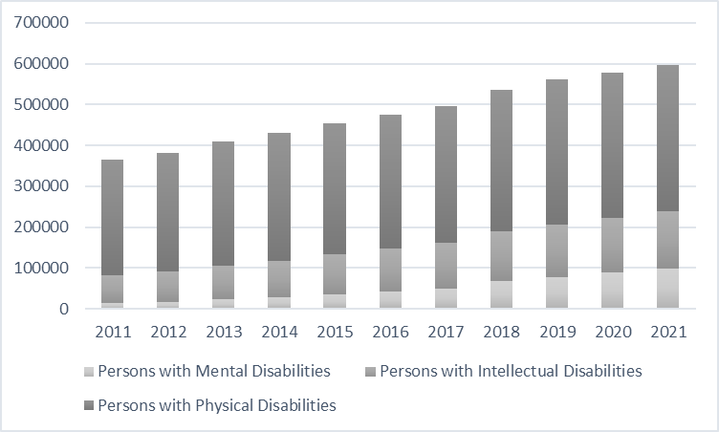
NOTE: This graphic is based on data from the Ministry of Health, Labor, and Welfare (2021).
At the same time, according to some persons with disabilities, they are unable to fully utilize their abilities in their place of employment. For example, a person with a mental disability indicated to the author that he obtained a mental disability certificate and joined a company with a disability employment quota. "I joined the company because I wanted to work, but my boss told me to browse the comics at a convenience store. My boss doesn't understand me at all." This highlights the problem that, in Japan, the purpose of employing persons with disabilities at times appears simply to hire them; companies may only see persons with disabilities without understanding and utilizing their gifts and talents. Consequently, many Japanese companies cannot envision how persons with disabilities work.
To clarify the structure of the problem, I would like to focus on the discussion of essential functions. Essential functions are an unfamiliar concept in Japan's system of hiring persons with disabilities. This is due to the belief that clarifying the essential functions of work in Japan leads to a merit system that creates persons with disabilities who cannot work. For example, Hanada (1991) and Yashiro (1991) pointed out that focusing on essential functions in Japan makes it impossible for persons with disabilities to obtain jobs. Therefore, when hiring persons with disabilities, most Japanese employers provide reasonable accommodations without considering the concept of essential functions.
Instead of focusing on essential functions, regarding the employment of persons with disabilities in Japan, greater attention is often given to communication skills. Analyzing previous papers on the abilities required of persons with disabilities in Japanese workplaces Kodama et al. (2020) found that, for persons with disabilities to demonstrate their abilities in the workplace, their work attitude and cooperation with superiors and colleagues are important. In 2005, the Ministry of Economy, Trade, and Industry published "Essential Competence." Kodama et al. pointed out that, out of the 12 elements of these guidelines, six relate to the ability to work in a team (2020). Furthermore, Inoue et al. (2012) bring attention to the fact that interpersonal communication skills are important for persons with disabilities to obtain employment. These discussions clearly suggest that many Japanese people view communication skills as a condition of employment.
Similarly, the Ministry of Health, Labor, and Welfare promote social skills training for the employment of persons with disabilities (2021b). It can be said that Japan’s employment policy for persons with disabilities emphasizes social skills training. Communication problems are often considered the reason persons with disabilities cannot find employment. Social skills training may have some positive aspects for improving the employment status of persons with disabilities. However, if a person with a disability cannot attain a job or adjust to a workplace after undergoing social skills training, he or she may be considered the cause of the problem. In other words, the problem is personalized. Therefore, Japan’s vocational perspective, which emphasizes communication skills, may hinder the employment of persons with disabilities.

Definitions of Essential Functions in the U.S.
Now, let us examine a discussion of essential functions of the workplace in the United States. According to The U.S. Equal Employment Opportunity Commission (EEOC), essential functions of the workplace are defined as the basic job duties that an employee must be able to perform with or without reasonable accommodation. According to Brannick (1992), the ADA requires employers to focus on the essential functions of a job to determine whether a person with a disability is qualified to perform the major functions of the job at hand. This clearly suggests that, in the United States, employers are required to pay attention to the "essential functions" and "reasonable accommodations" at work for a person with a disability to be recognized as a "qualified individual in the workplace."

Differences between the U.S. and Japan
To summarize the discussion thus far: in the United States, most people focus on the essential functions of a job and clarify the skills required for persons with disabilities to work. Consequently, people with disabilities can work to their full potential with the reasonable accommodations necessary to perform their jobs. In contrast to this, in Japan, most people do not focus on the essential functions of a job, and the skills required for persons with disabilities to work are ambiguous. Consequently, many people with disabilities cannot use their abilities to work because most receive only communication support.
Focusing on Coffee Workers with Disabilities in Japan
In Japan, which has a background of avoiding discussions of essential functions, there is insufficient research focusing on essential functions as a key to improving the work environment for persons with disabilities. However, some examples that Japanese society has evaluated as successful have many similar stories to those discussed in the United States in the context of essential functions. A typical example is a coffee worker with a disability.
For example, the Nikkei (2022) reports the following: an increasing number of employment support establishments and special subsidiaries are adopting "coffee" for work involving persons with disabilities. The work includes the production of one cup of drip bag and the operation of a cafe. These initiatives suggest positive outcomes with respect to division of labor, cooperation, and exchange. "Canvas," a business establishment that supports the employment of persons with disabilities in a commercial facility in Shizuoka City, is surrounded by a rich aroma after 10 am. "The feature of this work is that the work can be sorted according to the characteristics of our members," says Michiaki Mochizuki, the administrator. Kento Izumi, who dyes his hair pink and is registered with a modelling agency, says, “I am good at picking (selecting defective beans)" (The Nikkei, 2022).
These examples suggest that the coffee industry has been attracting attention as persons with disabilities have the opportunity to demonstrate their abilities and work. Good examples can be found all over Japan. One is Worker’s Home in Okinawa Prefecture, where employees with disabilities grow coffee on the land, roast it in-house, and serve the coffee at a cafe. Correspondingly, persons with disabilities can play an active role in coffee-related work even if they lack the communication skills required by Japanese society.
By focusing on the coffee industry, it may be possible to establish a relationship between essential functions and qualified individuals in the employment of persons with disabilities in Japan. A question based on our research is whether focusing on essential functions when companies hire persons with disabilities may allow the clarification of conditions under which persons with disabilities become qualified individuals and realizing the value of their employment.
Methods
Targeting all prefectures in Japan, we surveyed 401 companies and organizations in which persons with disabilities are engaged in coffee-related work. The survey period was July 31 to September 25, 2021. We received valid responses from 81 organizations, representing a response rate of 20%. We extracted groups by searching for the keywords "coffee," "café," and "roasting" in the activity introduction text of the registered group information of the Japan National Council of Social Welfare. From the organizations that employ persons with disabilities, we extracted the workplaces, organizations, and companies that appeared to be engaged in coffee-related business by conducting a thorough Internet search. We then excluded those that were clearly out of business or were considered inappropriate, listed the groups/companies by prefecture, and used them as a sample.
The questionnaire items revolved around the characteristics of facilities (sales, facility size, number of persons with disabilities, etc.), methods of managing employees with disabilities, types of work performed by persons with disabilities, reasonable accommodations for workers with disabilities, and the effects of COVID-19 on work.

Results and Discussion
First, the companies, organizations and individuals included in this research were as follows. Companies accounted for 15%, nonprofit organizations for 28%, social welfare corporations for 40%, and others for 17%. Social welfare corporations were the most common, at 40%. Regarding the types of disabilities of the employed persons, people with mental disabilities accounted for the largest proportion at 30%, followed by those with intellectual disabilities at 25%, and those with visual disabilities at 21%. The number of persons with hearing disabilities was 5%, the number of others was 4%, and the least was persons with visual disabilities at 3%. The average monthly wages for persons with disabilities were as follows. The rate of 16,300 yen or less is the highest, at 48%. More than 78,900 yen accounted for 32%, and more than 169,000 yen accounted for 15%. Regarding the last 5%: 4% earned between 5,000 and 16,300 yen, and 1% earned 220,000 yen or more.
Figure 2 addresses the question, "What kind of work is a person with disabilities in charge of?" Customer service and cleaning account for 13.6%, the highest percentage.

Figure 2
Work Performed by Persons with Disabilities
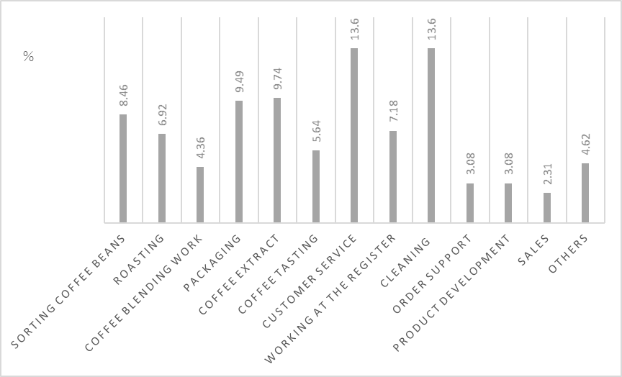
NOTE: This figure demonstrates the percentage of each job that a person with a disability oversees. The rate of sorting coffee beans is 8.46%. The rate of roasting is 6.92%. The rate of coffee blending work is 4.36%. The rate of packaging is 9.49%. The rate of coffee extraction is 9.74%. The rate of coffee tasting is 5.64%. The rate of customer service is 13.6%. The rate of working at the register is 7.18%. The rate of cleaners is 13.6%. The rate of order support is 3.08%. The rate of product development is also 3.08%. The rate of sales is 2.31%. The rate of others is 4.62%.
Figure 3 addresses the question, "What kind of work do you think is suitable for persons with disabilities?" The percentage of respondents who answered, "Sorting coffee beans" showed an increase from 8.46% to 11.1%.

Figure 3
Types of Work Suitable for People with Disabilities
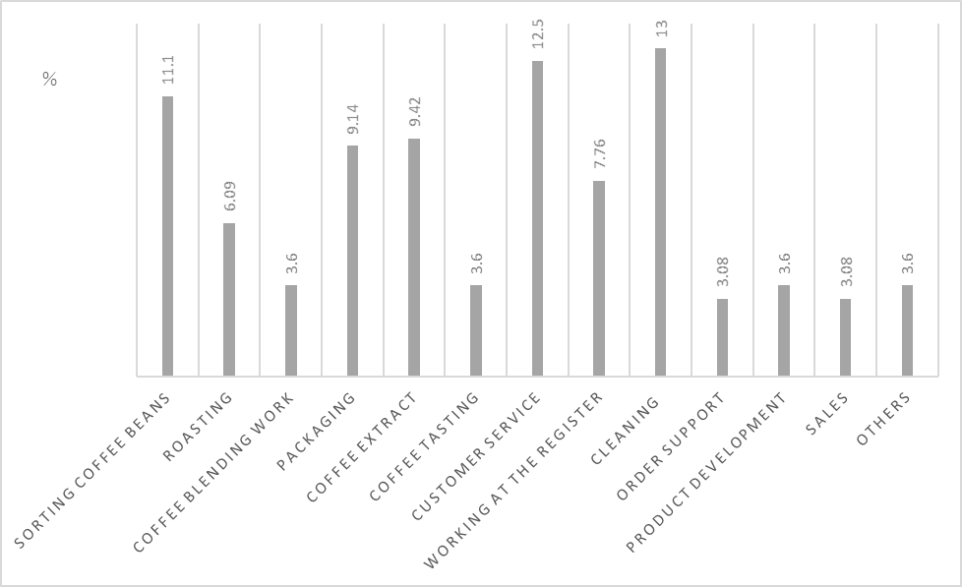
NOTE: This graph illustrates each percentage of work considered suitable for persons with disabilities. The rate of sorting coffee beans is 11.1%. The rate of roasting is 6.09%. The rate of coffee blending work is 3.6%. The rate of packaging is 9.14%. The rate of coffee extract is 9.42%. The rate of coffee tasting is 3.6%. The rate of customer service employees is 12.5%. The rate of working at the register is 7.76%. The rate of cleaners is 13%. The rate of order support is 3.08%. The rate of product development is 3.6%. The rate of sales is 3.08%. The rate of others is 3.6%.
This result inspired us to analyze the response data for the questionnaire in more detail. We suspected that the group conducting in-house roasting increases the proportion of sorting coffee beans. The group performing in-house roasting was defined as group A1, and the group not roasting coffee beans in-house was defined as group A2. Next, the response results were compared.
We conducted a Chi-square test, and the results revealed significant differences among the conditions (χ2(2) = 4.260, p = 0.0221704, φ = 0.213). Residual analysis revealed that group A1 preferred sorting coffee beans significantly more than group A2, and group A2 preferred customer service significantly more than group A1. In other words, it can be said that the group conducting in-house roasting could pay more attention to the essential functions required of coffee workers. It can also be said that organizations that do not perform in-house roasting place more emphasis on customer service skills that can be acquired through social skills training.
Then, which group of persons with disabilities is more valued by society? We re-analyzed the average monthly wage data and compared groups AI and A2. The average monthly wage was 22,932 yen for group A1 and 18,797 yen for group A2. Thus, there was a difference of 4,135 yen between groups A1 and A2. Organizations with employees with disabilities who sort coffee beans can pay higher wages. This result demonstrates that, that by focusing on the essential functions of coffee-related work, persons with disabilities can demonstrate their abilities and be evaluated by society through their work.
Among the groups of persons with disabilities who engage in coffee-related work, those who place importance on sorting coffee beans can perceive of jobs unique to the coffee industry as essential functions. However, organizations that emphasize customer service may not be able to focus on the essential functions that people with disabilities need to become qualified coffee workers.

Conclusion
The survey showed interesting results when considering the relationship between essential functions and qualified individuals. Organizations that consider bean sorting an essential function tend to pay higher wages to persons with disabilities compared to organizations that consider customer service an essential function. Whether the person in charge of the organization can conceptualize the skills necessary for coffee-related work as essential functions may be a condition for whether persons with disabilities can utilize their abilities to work. Promoting people with disabilities who work as qualified individuals may enhance their social evaluation through work. I am working on a project, the Manakiki Blend, to verify whether employees with disabilities can increase coffee sales by advertising that they are qualified individuals.
Unfortunately, our study did not include sufficient online participant observations and interview data. A more detailed analysis is needed to develop a complete solution to improve working environments for persons with disabilities. In the future, through this project, we will analyze whether companies and organizations can focus on essential functions so that people with disabilities can be regarded by society as qualified individuals and society can work with their abilities.

References
Brannick, J. P., & Levine, E. L. (1992). Job analysis, personnel selection, and the ADA. Human Resource Management Review, 2(3), 171–182. https://doi.org/10.1016/1053-4822(92)90010-N
Hanada Syuncho. (1991). ADA hou yabunirami [Casting our eyes to the ADA]. In Yashiro Eita & Tomiyasu Yoshikazu (Eds.). ADA no shogeki (pp. 122–130).
Inoue Masashi, Inoko Hidetaro, Kudo Takeshi, Ozawa Michimasa, Kikuchi Kazufumi, Wakui Megumi, & Osaki Hirofumi. (2021). Tokubetsushiengakko (chitekishoga）kotobu niokeru keidochitekishogainoaru seitoni taisuru kyoikukateini kansuru kenkyu: Hitsuyosei no takai shidonaiyo no kento [Study on a curriculum for students with mild intellectual disability in a special needs school (intellectual disability) high school: Examination of highly necessary instruction content] National Institute of Special Education.
Kodama, M., & Takamura, T. (2020). Hattatsushogaisha no shuroshien no genjo to kadai: Shokuba no ningenkankei ni chakumoku shite [Current status and challenges in employment support for persons with developmental disabilities: Focusing on interpersonal relationships in the workplace]. Bulletin of Center of Clinical Psychology & Counseling at Ochanomizu University, 22, 63–74.
Ministry of Health, Labor, and Welfare. (2021a). Reiwa sannendo shogaisha koyojokyo no shukeikekka [Reiwa 3rd-year total results of employment statuses of persons with disabilities]. Retrieved March 29, 2022, from https://www.mhlw.go.jp/content/11704000/000871748.pdf.
Ministry of Health, Labor, and Welfare. (2021b). Hattatsushogaisha shienseisaku no gaiyo [Outline of support measures for persons with developmental disabilities]. Retrieved March 29, 2022, from https://www.mhlw.go.jp/stf/seisakunitsuite/bunya/hukushi_kaigo/shougaishahukushi/hattatsu/gaiyo.html.
The Nikkei. (2022, January 6). Coffee work encourages people with disabilities, coordinates with the Division of Labor, and refines barista skills. The Nikkei. https://www.nikkei.com/article/DGKKZO78981550W2A100C2KNTP00/
Yashiro, E. (1991). Nichibei kankei Kokusai kankei soshite Nihon [US−Japan relations, international relations, and Japan]. In Yashiro Eita & Tomiyasu Yoshikazu (Eds.). ADA no shogeki (pp. 369–416).

Focusing on Essential Functions for Persons with Disabilities to Improve Working Environments: From a Survey on Coffee Workers in Japan by Wakaba Hamamatsu and Kuniomi Shibata https://rdsjournal.org/index.php/journal/article/view/1175 is licensed under a Creative Commons Attribution 4.0 International License. Based on a work at https://rdsjournal.org.

