Research Articles and Essays

The Virtual Shift: Early Childhood Intervention Therapies for Pakistani Children with Down Syndrome During COVID-19
Huzaifa A. Khan¹, Samar Naqvi², & Sidra Zahid³
^{1, 2, 3} Karachi Down Syndrome Program,
Karachi, Pakistan
Abstract
The paper aims to discuss the impact of Karachi Down Syndrome Program (KDSP)’s virtual Early Childhood Intervention (ECI) service, comprising of speech and language therapy, occupational therapy and physical therapy clinics, on children with Down syndrome and their parents in Pakistan during the COVID-19 pandemic from March 2020 to August 2020. The results yielded many positive outcomes of the virtual shift and allowed for continuous innovation in empowering parents and transforming the developmental outcomes of children with Down syndrome.
Keywords: Down Syndrome, early childhood intervention, Pakistan

Down Syndrome
Every cell in the human body has chromosomes containing DNA that determines an individual’s characteristic traits. Typically, each cell contains 23 pairs of chromosomes. Down syndrome occurs when an individual has a full or partial extra copy of chromosome 21. This additional genetic material alters the course of development and causes the characteristics associated with Down syndrome. A few of the common physical traits of Down syndrome are low muscle tone, small stature, an upward slant to the eyes, and a single deep crease across the center of the palm – although each person with Down syndrome is a unique individual and may possess these characteristics to different degrees.
According to the World Health Organization (WHO), out of every 700 babies born around the world, 1 will have Down syndrome. The condition affects people of all ages, regardless of race, religion and economic situations (What Is Down syndrome, 2021).

About The Karachi Down Syndrome Program
The Karachi Down Syndrome Program (KDSP) is a non-profit organization, launched in March 2014 by a group of concerned parents and passionate individuals who due to limited support and resources available locally, realized a need for a platform for those with Down syndrome. KDSP was formed with the mission to advocate the value, acceptance and inclusion of people with Down syndrome living in Pakistan and aims to provide them with the opportunity to lead independent and fulfilling lives. This is done through KDSP’s 6 areas of service:
- Khandani Sahara – Family Support
Family Support provides families of individuals with Down syndrome emotional, financial and informational support.
- Agaahi – Awareness
Awareness aims to raise awareness and perpetuate the correct perceptions in society through public events and digital media avenues.
- Sehat – Healthcare
Healthcare at KDSP is provided by partnering up with leading hospitals across Pakistan to provide high quality healthcare at subsidized costs through the organization’s support.
- Hunar – Enrichment and Skills Development
Enrichment and Skills Development aims to equip individuals with Down syndrome with important, life-long skills that they can utilize to achieve self-fulfillment. The department runs 17 programs that include skills like swimming, fitness training, cooking and baking, arts and crafts as well as virtual reality integrated games.
- Taleem – Education and Training
Education aims to integrate children with Down syndrome into mainstream schools. There are 4 programs running at KDSP to educate and prepare young children aged 0-14 for formal schooling ahead. Simultaneously the department works with external institutions to train them in inclusive education practices catering to individuals with Down syndrome.
- Ibtidayi Bunyaad – Early Childhood Intervention
Early Childhood Intervention at KDSP comprises of occupational, physical and speech and language therapy; delivered to children between the ages of 0-7 in order to help them fulfil their necessary developmental milestones.
Innovating Through the Pandemic
The outbreak of COVID-19 initiated in December 2019 in Wuhan, China, and soon after spread rapidly across the globe. On January 30, 2020, the World Health Organization (WHO) declared the coronavirus outbreak as the sixth public health emergency of international concern (PHEIC), and on March 11, 2020, it was announced a pandemic. The WHO warned Pakistan that the country with its estimated population of 204.65 million, could encounter great challenges against the coronavirus (Khadijah Abid, 2020). Soon the first case was reported from Karachi on February 26, 2020, and by March 2020, major cities went into complete lockdown.
In the wake of the rapid spread of the virus, KDSP decided to convert all in-person services for children with Down syndrome and their parents, to virtual services in order to safeguard their lives because children with Down syndrome tend to have low immunity accompanied by a number of underlying health conditions which could be triggered due to exposure to the coronavirus.
KDSP’s 6th area of service, i.e., Early Childhood Intervention (ECI), focuses on early intervention and the necessary occupational, physical and speech and language therapy crucial for the development of a child with Down syndrome. Early intervention can help in many ways. During the first three to four months of life, for example, an infant is expected to gain head control and the ability to pull to a sitting position with no head lags and enough strength in the upper torso to maintain an erect posture. Appropriate physical therapy may assist a baby with Down syndrome, who has low muscle tone, in achieving this milestone. Early intervention can also prevent a child with Down syndrome from reaching a plateau later on in development. Thus, the goal of early intervention efforts is to enhance and accelerate development by building on a child’s strengths and by strengthening those areas considered weaker, in all aspects of development (Programs: Early Childhood Intervention, 2021).
The following paper, will be detailing the initiatives, events, outcomes and results of KDSP’s ECI virtual therapies and supporting efforts during the pandemic for sustained growth and development of children with Down syndrome.
Figure 1
A timeline of events since March-August 2020
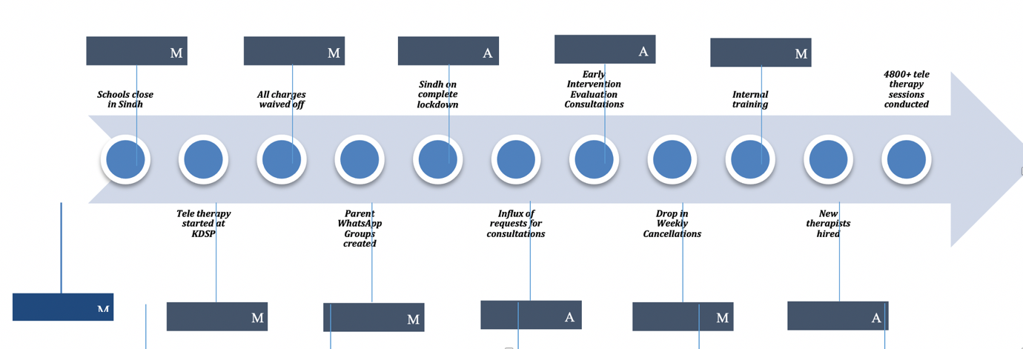
Virtual therapy
The first years of life are critical in a child’s development. During these early years, they achieve the basic physical, cognitive, language, social and self-help skills that lay the foundation for future progress. These abilities are attained according to predictable developmental patterns (National Down Syndrome Society, 2021).
Since children with Down syndrome typically face delays in certain areas of development (National Down Syndrome Society, 2021), early intervention helps make sure those delays aren’t prolonged. Considering this, it was crucial that the children enrolled with KDSP continue to receive regular therapy. This was achieved by adopting virtual therapy practice, conducting one-on-one sessions online via WhatsApp video and audio calls with 170+ children with Down syndrome enrolled in the ECI clinics. These calls were made based on pre-set schedules and each one lasted for a minimum of 20 minutes, while the maximum went on for above 45 minutes. Therapists would divide their time engaging directly with the children and counseling parents/caregivers, training them to follow along the therapist’s instructions.
Therapists set up resources online and used engaging techniques to make children as well their parents/caregivers comfortable with the new mode of therapy. It was also decided to waive the charges for all therapy sessions until June so that the parents/caregivers could ease through the process of adapting to the new normal.
Since 14th March when operations moved online, an average of 181 virtual therapy sessions were successfully conducted weekly leading to a total of 4800+ virtual therapy sessions conducted digitally since the lockdown (until August, 2020), with children showing signs of progress as they received regular support from the therapist as well as their parents/caregivers.
Case in Point:
Narrated account by: Maha Khan, Occupational Therapist at KDSP
My client Mustafa [K.] is 2 years old and has shown progress while taking virtual therapy. Initially it was challenging to figure out the best way to engage with him and his mother and we went through a trial and error period.

We started off with video calls, but saw that Mustafa was distracted very easily by the phone and the mother had to keep him at bay which did not help with my goals. We switched to audio calls with the mother only, but soon observed that there was no progress in Mustafa. Finally we agreed to use both the audio and video features and divide the time of the session effectively into 3 parts-I dedicated the first 10mins to speak to the mother on audio call where I shared my plans with her, explained the activity, the sitting arrangement needed for it and the delivery techniques to be used, as well as the possible hindrances that could arise during the activity.

The next 25-30 mins were spent on video call where the camera was hidden from Mustafa and I would only observe the mother carrying out the activity with him without passing on any instructions to her or taking any questions from her. In the 3rd part, I would get on audio call with the mother again for the last 5-7mins and give her feedback according to my notes and address her questions. This proved to be a very effective strategy and we were able to see progress in Mustafa as he was able to focus on the work being done and slowly became used to the phone being near him without getting distracted by it.

We also had to find our way through the challenge of not having any therapy and activity material at home. We used household items like cardboard, kitchen supplies, toys, colors, etc. to prepare activity material for Mustafa-I used pictures and videos to show the mother what she had to make and then spoke to her in detail over the phone as she prepared the material.

Overall, our combined efforts helped Mustafa tremendously and we observed an improvement in his fine motor skills. His sitting tolerance increased from 1 minute when we started to Mustafa being able to sit and work for 20-25 minutes at a stretch now.

We also got a great opportunity to work on his toilet training. This was not possible earlier (pre-virtual shift) because the mother would be busy and Mustafa would be engaged in other activities during the day. Now that the mother found more time during quarantine, she was able to dedicate time to train Mustafa and the results came soon!

Mustafa’s progress can be attributed not only to the fact that his mother has more time now, but also to her new-found sense of responsibility. Previously when Mustafa used to come to KDSP, I would give the mother home plans, but she would not be able follow them; however, now after she has had the opportunity to physically engage with Mustafa herself and see the results hard work can bring in, she has become quite proactive and is always sending me videos and pictures of her working with Mustafa, asking how to improve what she is doing. It is beautiful to witness this!

Such progress is not just observed in Mustafa, but in several other clients as well. There is an overall shift in the sense of responsibility that parents are now carrying towards their children and with our support they are able to channel it to achieve the best outcomes for their children.

Figure 2
Set of lacing beads made from bottle caps and shoe laces.
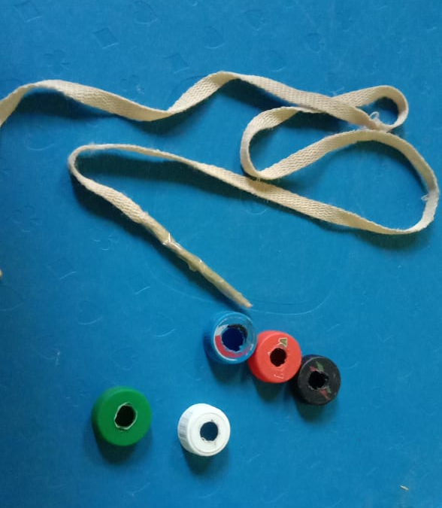

Staying Connected
In an attempt to connect with the parent community and offer support in the wake of unsettling times, personalized phone calls were made to parents of children enrolled in the ECI clinics. As a result, while some parents got a chance to express their concerns and share their changing needs, others took the opportunity to pass on their gratitude to the organization for going the extra mile for their children.
Furthermore, dedicated WhatsApp groups were set up with parents/caregivers for each therapy faculty i.e. Occupational Therapy (OT), Physical Therapy (PT) and Speech and Language Therapy (ST). These groups served as platforms to help stay connected with the parent community and to share resources that would help them engage their children meaningfully in activities and exercises at home. These groups continue to be active to date with several resources shared on a weekly basis with the parents.
Internal Training
In order to share resources further internally within the organization, a virtual training experience was launched. Each therapy department developed and conducted a workshop on their area of expertise and trained their colleagues from various departments in the organization on the basics of Occupational, Physical and Speech and Language Therapy. To date four such experiences have been organized and attended by a total of 50 participants.

Literature Review
Common factors associated with Down syndrome are physical and cognitive developmental delays. Children with Down syndrome achieve certain milestones later on in life or require specialized, dedicated help in developing their abilities (Vicari, 2006). Hindrances in activities like walking, sitting properly, being able to communicate can in turn have adverse effects on multiple other aspects in the child’s life, ranging from their confidence and self-perception to their ability to learn and employ various skills to sustain independent life. If unaddressed, these psycho-social factors can further lead to more detrimental mental health conditions like anxiety or depression (Wales, Skinner & Hayman, 2017). To overcome the challenges posed, early childhood intervention is a crucial factor in shaping the development of these children. The delivery of essential therapies sets the basis for skills and behavior development all the way into adulthood. Majority of the brain’s capacity for higher functions is formed around the age of 3-5 and children learn at much quicker rates in their youth than adulthood (Tufail, 2011). Despite the developmental delays in Down syndrome, biological processes develop and age at a typical rate thus emphasizing the need to act in the early stages of life i.e. 0-7 years. During this sensitive age, children require a great deal of care and attention so they can function better in terms of behavior and well-being (Smees & Sammons, 2017).
The prevalence of intellectual disabilities is quite high in Pakistan which coupled with the lack of awareness regarding conditions like Down syndrome, exhibited by both parents of children with Down syndrome and doctors in small scale and public hospitals proves to be a detrimental combination. In a study conducted by Ahmed et al (2015) it was found that most diagnosis for Down syndrome were done much later in the life of the child, after the age of early intervention had passed. Even when doctors could diagnose Down syndrome based on physical features, they were unable to name the condition correctly and miscommunicated it to parents who as a result were unable to find proper resources and support for their children when health and social complications arose. In the face of this knowledge gap, the primary concern of parents was regarding the quality of life their children would lead and their mental development, demonstrated through poor speech and language skills. For effectively improving the outcome of life of a child with Down syndrome, it is crucial to provide therapies soon after birth. Efforts should also focus on empowering parents and providing them with the basics of coping with their children’s needs.
Primary care services are scarce in Pakistan, the few hospital providing child development services are expensive, simultaneously high in demand, yet difficult to access. Even if services exist, they remain unregulated and unsupported, therefore proving grossly inadequate (Khan et al, 2017). For developmental delays in Pakistan, prevalence is at an estimated 15% for children in middle-income households and 30% for children from impoverished backgrounds (Durkin, Hassan & Hassan, 1995). Majority of the population cannot access or afford to seek medical care from the few specialists available in the country. Studies have demonstrated that socio-economic backgrounds have a significant effect on the child’s ability to learn and pick up on new techniques. While the learning environment is a more important factor, the socio-economic status of a family, does contribute to the amount of time parents spend with the children, the resources they can access and the kinds of activities they focus on practicing with their children (Law et al, 2017). During 2020, the severity of the pandemic meant a lot of instability for parents and additional financial constraints. Many people lost their sources of income and their lives were displaced, forcing them to face a plethora of new challenges. While being placed under strict lockdown further prevented people from accessing the regular services they availed. In the face of such adversity, parents shifted their focus and parents with multiple children had greater difficulty in managing the individual needs of every single child (Smith and Barron 2020). Parents who had children with special needs were even more worried about the negative impacts on their children as they were unable to attend their childcare services (Pascal et al, 2020).
In a study conducted by Feinberg (2012) exploring the link between racial backgrounds and access to crucial early intervention services, it was found that discrepancies arose in availing services when developmental delays were a part of the equation. Certain races also belonged to lower income backgrounds. In Pakistan there too exists a disparity in socio-economic backgrounds with approximately 40% of the population reduced to living below the poverty line in the wake of the pandemic (UNDP, 2020). This disparity affects accessibility to early intervention services between urban and rural areas as well as communities from different provinces.
In contrast, the occurrence of the pandemic opened up an array of opportunities for some. Means of digital transformations have become increasingly common in many industries, not evident in the healthcare industry. While there are many aspects to this discussion, involving the nature of the healthcare industry and the sensitive information and patient care involved, current circumstances have made apparent that adopting digital platforms are among the best solution to thriving ahead. Hermes et al (2020) stated how remote and on-demand healthcare can be beneficial in providing easy and convenient services at a larger scale. Customers can utilize 5G, cloud computing and a variety of apps to avail their preferred services. At the same time healthcare providers can use the same tools to provide information and guidance. The article emphasizes how digital means can help empower customers as they play a more active role in their healthcare provision.
Wilson & Waddell (2020) noted that in cases where therapy practitioners were able to utilize digital means of communication, new benefits emerged. Whereas earlier many parents had to endure long waiting lists before receiving support, now therapists had the capacity to deliver sessions in greater quantity. The success of this model was however dependent entirely on the flexibility of services delivered and the adaptability of the service providers. For some the provision of therapy digitally also reduced costs and time barriers that otherwise prevented them from availing services.
Another useful tool that also emerged was through parents now recording sessions. In a study conducted on physical therapy services, recordings made were shared with the therapists who could monitor the parents delivering the sessions, identify and improve delivery of therapy and maintain a progress record of the child’s development. This helped determine the efficacy of specific therapy techniques. The documented videos could further be shared with other parents as examples of the methodology to employ in their own households, thereby saving time that the therapist would have to otherwise allot to each family (Rao, 2021). The lockdown period gave practitioners ample time to experiment with digital therapy delivery methods and devise family centric and home based therapies. Parents were pushed to seek alternatives for professionally utilized tools..
While therapists deliver in-person sessions, the role of the parents is usually reduced. As most therapies conducted aim to achieve independent functioning of young children, the primary caregivers take a step back. It is important to note that parents were found to play the most influential role in the lives of the child and can connect better with them. Regarding physical developmental milestones, the most favorable results of early interventions were achieved when parents were able to engage more responsively with their children, playing a more interactive role rather than observational (Mahoney & Wiggers, 2007). This finding was consistent with studies conducted across a multiple developmental disabilities including Down syndrome (Mahoney & Perales, 2006). In speech and language therapies, parents using infant directive, responsive speech can reinforce several skills from differentiating the sound of words, to assigning meanings to these sounds and words and even associating emotions with the words used (Axford & Albers, 2018). Increased involvement of caregivers in therapy delivery could promote quicker, long term results through a more nurturing environment. However that does not imply that parents can take up the sole responsibility of delivering therapies. Manfred (2000) observed that parents felt more supported as the members of the family involved in early childhood intervention process increased. The research further stated that caregivers felt dissatisfied if therapists lagged or held back in communication, concluding that regular feedback meetings, documentation and progress tests increased parent satisfaction and therefore child-parent interactions. It was confirmed that parents were willing to accept more responsibility and involvement in their child’s therapy, they were unable to do so due to time and schedule constraints (Sayers, Cowden & Sherrill, 2002).
In another study conducted prior to the pandemic, the impact of digital delivery of therapy and psychological treatments was explored, with the findings emphasizing on blended methods of treatment as the best course of action. These treatments relied both on caregivers as well as therapy practitioners, incorporating support lent by supervising sessions that were conducted digitally, with the clinician taking a step back to advise on how best to deliver a treatment and then ensuring that it is conducted properly. This same study also identified several challenges arising from cultural context, including the Indian region whereby the pool of therapists was already scarce and many people did not know about the therapies required. The researchers were hopeful that incorporating digital means into their routine therapies would help surpass this barrier as the therapists would face less constraints without great physical involvement (Fairburn & Patel, 2017). Through COVID-19 this practice has been put to the test.
The pandemic has demonstrated that adapting to the changing situations around is crucial in succeeding and fulfilling goals. The framework of care has shifted to have increased involvement of parents of children with disabilities. Despite the introduction of unique psychological stressors that now plague households, parents spending more time together might mean that caregivers are able to allocate more attention to the development of their children. Fairburn & Patel (2017) also discussed that certain aspects of therapy, require a more hands-on approach, and for years, pediatric care has emphasized the need of a family-centric approach to child development with significant evidence depicting the increased satisfaction of all members regarding the services as well as the ultimate results. The paper further recognizes the need for alternate methods of delivering therapies for individuals with disabilities due to the increased risk of infection accompanying their low immunity.
Due to the fact that such programs are rarely found in the South Asian region, there is a lack of data pertaining to the socio-demographic of the Pakistani population. While the resources available can differ across regions, children with Down syndrome from all parts of the world must fulfil similar developmental milestones on their way to adulthood. Therefore, they must receive similar early childhood intervention therapies that are customized to their individual needs.
Methods
The impact of the interventions conducted during the lockdown, discussed above was assessed using internal monitoring tools and reports, collecting one-to-one feedback from parents and therapists through phone calls and conducting a telephonic survey with parents of children enrolled in virtual therapy at KDSP. The latter was administered through a questionnaire with 100 parents, who were selected at random from a pool of parents of the 170+ children with Down syndrome enrolled in virtual therapy at KDSP. Their responses were recorded, tabulated and analyzed by using Microsoft Excel tools.
Results
Results from studying the monitoring records, speaking to parents and therapists and looking at the results of the telephonic survey revealed that the shift to offering virtual therapy services and virtual support to parents had a significant impact on the gross motor, fine motor and speech language development of children with Down syndrome. There was a demonstrated increase in parental involvement, the organizational team was pushed to focus on innovation and allowed KDSP to expand its reach to children with Down syndrome beyond Karachi as well as a drop in the number of cancellations of sessions.
Figure 3
Results of survey, 100 parents of children with Down syndrome enrolled in virtual therapy at KDSP
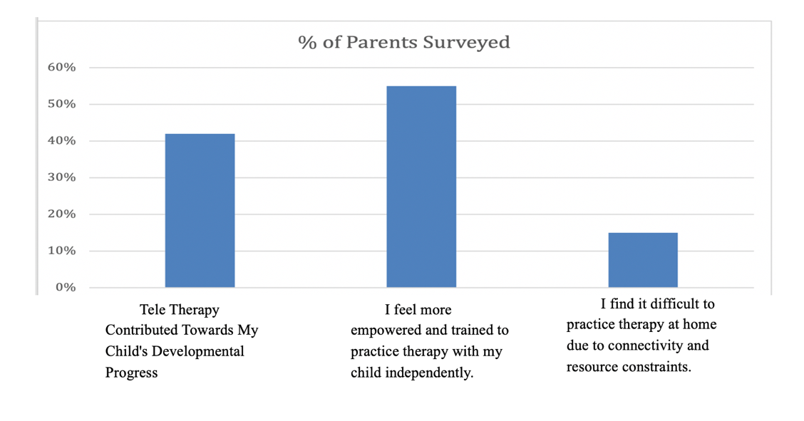

Increased parental involvement
Going virtual with therapies for children enrolled in the ECI clinics pulled parents into action, more effectively than ever before. This change came in because the therapist was now at a distance, passing on instructions through video. The parents were the ones who were involved with the child physically, assisting him/her to follow through and later taking notes from the therapist on what exercises to carry on at home and how. The team found this change particularly exciting because over time it could bring in positive results in the child’s progress. It was noted that a direct result of increased parental involvement in therapy was that children’s toilet training has picked up pace and their performance on ADLs (Activities of Daily Living) like brushing teeth, changing clothes and cleaning around the house, has improved.
Additionally, it was observed that the relationship between the therapist and the parents grew stronger as result of greater involvement. Interestingly even the parents who used to be involved only passively during physical sessions or would not accompany their child into the therapy room, prior to the pandemic, were now taking on a more active role.
42% of parents surveyed reported that virtual therapy sessions contributed towards their child’s developmental progress.
Innovations introduced to support parents practice therapy with their children at home
Innovative strategies were employed to keep the children and their parents engaged. A number of therapists began to use dolls to demonstrate exercises. Similarly, some therapists brought in digital games and used the support of applications like Zoom to make the interaction more engaging for their clients.
They went the extra mile to support parents in creating resources and tools needed for therapy with material available at home. For example, using tape to mark lines on the floor for the child to follow and practice their walking, utilizing a stool in place of a walker, creating a parallel bar set up at home using PVC pipes and other innovative and cost effective ideas.
Additionally, many therapists started encouraging parents to record videos and pictures of their children while performing assigned tasks and exercises. While this helped the therapists visually track better the child’s progress and identify areas of concern, it also allowed for parents to become actively engaged as they regularly sent videos and pictures to their child’s therapist. Furthermore, these became resources that therapists were then able to share (with consent) with other parents as their source of learning. As a result, 55% of the parents felt more empowered and trained to practice therapy independently with their child at home.
In Speech and Language Therapy particularly, the team incorporated play into their practice and encouraged, and trained parents, to use the same. This proved to be beneficial in allowing the parents to establish stronger connections with their children and see visible progress in their communication. For example, one of the clients enrolled reported to have developed new vocabulary recently as a result of constant attention by the parent and the therapist.
Drop in Cancellations
Previously cancellations for sessions were recorded when a scheduled therapy session did not take place because the parents were unable to attend the session or the therapist was unable to attend to them at the allotted time or the session did not take place due to unforeseen circumstances. Since virtual therapy sessions did not require parents to commute to the clinics and they could benefit from the service from the comfort of their homes and setup convenient schedules for themselves, there were fewer cancellations recorded from March onwards.A 28% drop in cancellations was recorded when comparing average weekly records from November 2019 to February 2020 (pre-pandemic) and March 2020 to June 2020 (during pandemic).
Expanding KDSP’s reach beyond Karachi
Another impact of virtual shift was that it allowed KDSP to extend its reach far beyond Karachi, as physical barriers such as commute, in-person interactions and payments were removed. A large number of parents of children with Down syndrome who lived in other cities of Pakistan, especially rural Sindh and Punjab, as well as a few from outside the country, began requesting virtual therapy services as soon as these were introduced and were subsequently enrolled. A 26% increase was recorded in out of city therapies scheduled due to ease of access and 19 new children with Down syndrome from outside of Karachi were enrolled in therapy.
Additionally, as the message spread further, parents of children with Down syndrome even above the age of 7 years sent in requests for consultations and senior therapists were engaged to address the incoming needs through early intervention evaluation consultations via audio/video calls-they heard the parents’ concerns, assessed the child’s developmental needs and provided the parents with a basic plan on how to work on the same while at home. Early intervention evaluation consultations were audio/video call consultations provided once to a family, over a period of 3-6 months, with the aim to address their most urgent questions regarding their child’s development and to provide a basic therapy plan for them to follow with their child at home. Since March, a total of 21 additional early intervention evaluation consultations have been conducted, including those from areas outside of Karachi.
Limitations
The research elements in this paper were based upon responses and data collected from the population of children with Down syndrome between the age of 0-7 years residing in Pakistan and more specifically in Karachi. Therefore the results and the process as well as the impact of the interventions discussed in this paper cannot be generalized to apply to the entire population of children with Down syndrome in Pakistan or around the world or to those above the age of 7 years.
Additionally, the sample surveyed and studied for the purpose of this paper was based on convenience and comprised only of children enrolled in Early Childhood Intervention services at KDSP. In order to obtain a more accurate representation, a study must be conducted with a larger sample.
Since the recipients of early intervention services at KDSP span people of different backgrounds, hailing from different areas of the country, the access to resources for at-home and remote therapies was also very varied. Despite the innovations introduced by therapists as well as the efforts to deliver therapies consistently, the results have been influenced by confounding variables affecting the parents like strength of internet connections and hardware (cell phone, smart phone, and laptop) utilized during virtual therapy, including camera and microphone qualities.

Discussion
At a time of drastic changes, KDSP shifted its services to the virtual realm to continue providing constant essential services to children with Down syndrome. As a new exploration of capacities and therapy method, there was a great deal of learning and room for innovation involved. Each intervention planned and executed in response to the pandemic since March, has been a need based one, meaning that it is drawn from insights collected and concerns identified from among the parents involved with KDSP, who avail one or more of the services provided by KDSP. This enabled the team to keep their energies focused and offer support to the family network in ways that proved to be meaningful for both. The decision to move therapy services online and temporarily waive off subsidized therapy fee was taken to ensure that children enrolled in the ECI clinics could continue achieving their developmental milestones at an unhindered pace, and to offer a safety net for parents/parents who were financially impacted due to COVID induced job losses.
The aforementioned efforts made by KDSP, along with several others including providing early intervention evaluation consultation, staying connected with distressed parents and going the extra mile to support them in taking on a more active role in their child’s therapy, lead to increased parental involvement, pushed the team of therapists and parents to focus on innovation, allowed KDSP to expand its reach to children with Down syndrome far beyond Karachi and brought a drop in cancellations.
Despite these positive outcomes, a number of challenges also surfaced. One immediate challenge the team faced after going virtual was that time boundaries were blurred. The therapists took some time in adjusting to new schedules and parents found themselves reaching out to their therapists at odd hours or at unscheduled times because they had missed their designated time slot and were eager to connect with the therapist to address their pressing concerns and questions. Both the therapists and the parents were setting up to navigate through a new space and its associated challenges as well as the emotional stress that comes along with those. Fortunately, by establishing firm time boundaries and adjusting schedules for those parents who were not able to meet their previous commitments, this challenge was overcome to a great extent and the additional pressure for the therapists was removed so that they could focus wholeheartedly on their clients while taking care of themselves.
Since a number of parents associated with KDSP come from humble backgrounds and from areas that are far off, they did not have access to reliable internet services and thus connectivity come up as a challenge as the team has moved forward with the virtual shift. 15% of the parents surveyed as part of this research reported finding it difficult to practice therapy with their child at home due to connectivity issues and/or a lack of resources at their disposal.
In order to overcome this however the team was able to identify those parents with no or very poor internet access or those that do not own a smart phone and offered them therapy services via regular phone calls. This way, although the therapist was unable to see and interact with the child directly, they were able to connect with the parents and guide them on how to work with the child, while asking for regular updates and staying connected through text messaging. At KDSP, no one is left behind.
Additionally, connectivity issues also played in at times during otherwise smooth interactions via WhatsApp video calls. Electricity outages, no data or simply weak connections often caused calls to break and as a result children lose attention and at times parents tend to become agitated as well. This is a difficult challenge to overcome fully, however therapists made up by giving extra time to the client in the next session or reconnecting with the parent again at a different time during the day.
Since the country-wide lockdown was imposed almost overnight and operations moved online within a few days after, parents did not get a chance to fully equip themselves to practice therapy at home. Additionally a number of parents could not afford to invest in basic therapy material and equipment like gym balls, parallel bars, flashcards, functional objects, etc. This meant that their children’s therapy could be hindered, however the team of therapists at KDSP supported parents in helping them learn how to use items easily found at home to practice therapy with their children, including plastic cups and saucers, dolls, stools, etc. Some parents were even taught how to build their own resources, one parent of a child enrolled in Physical Therapy who was required to practice his walk regularly, were trained to set up a parallel bar system in their house using PVC pipes and duct tape which was cost-effective and ingenious. Similarly a number of parents were trained to build their own equipment and make the best use of all resources at home in order to ensure that their children continue to receive support.
With an influx of requests coming in for virtual therapy and early intervention evaluation consultations from all over the country, in addition to serving the existing clientele, coupled with the constant need of learning from and adapting to a changing environment, the team of therapists found themselves stretched for time and energy. They had to stay constantly connected with parents, train them extensively and support them emotionally as well. In order to avoid burn-outs and enhance capacity, support was brought to the team in the form of close supervision and guidance from the Head of Departments, training opportunities on how to maneuver through the online realm and efficient scheduling to ensure that all therapists get a break during their otherwise packed day. Additionally, 2 therapists were newly hired during this time to increase the department’s internal capacity and cater to the clients waiting for their turn to begin virtual therapy.
Conclusion
Although the virtual shift has brought in its own set of unique challenges, it has also opened up several new opportunities for innovation and progress. Increased parental involvement and deeper connections forming between parents and therapists were observed as initial successes among others. A positive outcome of this was in the form of progress among children taking virtual therapy.
Moving forward, KDSP can introduce a new system and improve the existing ones to support the family network including, offering temporary financial aid to parents who are adversely effected by the pandemic, creating a digital guidebook containing a vast array of activities and exercises parents can use with their children at home, introducing capacity building programs for therapists and parents/caregivers, and enhancing e-health services available for children with Down syndrome. Regardless the pandemic has opened up a plethora of possibilities to try out and maintain even in regular times that will allow for KDSP to reach out to more children and parents in need of early intervention services, and offer them more efficient therapies with increased beneficial results.
Focusing on such innovative and accommodating strategies can improve the provision of early intervention services across the country at a more macro level to reach more children who require these necessary services. As restrictions have shown to be reduced and parents more willing to make efforts and cooperate, it is up to the healthcare industries to come forward and apply these learnings in order to grant more children with developmental delays, access, especially in an environment comfortable for them while being conducive to their progress.
References
Axford, N., & Albers, B. (2018). Evidence Review: Improving the early learning outcomes of children growing up in poverty
Ahmed, K. J., Ahmed, M., Jafri, H. S., Raashid, Y., & Ahmed, S. (2015). Pakistani mothers' and fathers' experiences and understandings of the diagnosis of Down syndrome for their child. Journal of community genetics, 6(1), 47–53. https://doi.org/10.1007/s12687-014-0200-6
Durkin, M. S., Hasan, Z. M., & Hasan, K. Z. (1995) The ten questions screen for childhood disabilities: its uses and limitations in Pakistan. Journal of Epidemiology & Community Health. 49(4):431–436. http://dx.doi.org/10.1136/jech.49.4.431
Fairburn, C. G., & Patel, V. (2017). The impact of digital technology on psychological treatments and their dissemination. Behaviour research and therapy, 88, 19–25.
Feinberg, E., Silverstein, M., Donahue, S., & Bliss, R. (2011). The impact of race on participation in part C early intervention services. Journal of developmental and behavioral pediatrics: JDBP, 32(4), 284–291.
Hermes, S., Riasanow, T., Clemons, E.K., Böhm, M., & Krcmar, H. (2020). The digital transformation of the healthcare industry: exploring the rise of emerging platform ecosystems and their influence on the role of patients. Business Research. https://doi.org/10.1007/s40685-020-00125-x
Khadijah Abid, Y. A. (2020). Progress of COVID-19 Epidemic in Pakistan. Asia Pacific Journal of Public Health, 154-156.

Khan, M. A., Owais, S. S., Blacklock, C., Anil, S., Ishaq, S., Maqbool, S., Khan, H. J., Minhas, F. A., & Walley, J. (2017). Delivering integrated child development care in Pakistan: protocol for a clustered randomised trial. BJGP open, 1(1), bjgpopen17X100677. https://doi.org/10.3399/bjgpopen17X100677
Law, J., Charlton, J., & Asmussen, K. (2017). Language as a child wellbeing indicator
Mahoney, G, & Perales, F. (2006) The role of parents in early motor intervention. Down Syndrome Research and Practice, 10(2), 67-73. https://library.down-syndrome.org/en-us/research-practice/10/2/role-parents-early-motor-intervention
Mahoney, G., & Wiggers, B. (2007). The Role of Parents in Early Intervention: Implications for Social Work. Children & Schools, 29(1), 7–15. https://doi.org/10.1093/cs/29.1.7
Manfred, P. (2000). Early Intervention in Children with Down's Syndrome: From Evaluation to Methodology. Infants & Young Children, 12(3).
National Down Syndrome Society. (2021). Resources: Early Intervention. Retrieved from https://www.ndss.org/resources/early-intervention/
Pascal, C., Bertram, T., Cullinane, C., & Holt-White, E. (2020). COVID-19 and social mobility impact brief: early years.
Rao, P.T. (2021) A Paradigm Shift in the Delivery of Physical Therapy Services for Children with Disabilities in the Time of the COVID-19 Pandemic, Physical Therapy, 1(101).
https://doi.org/10.1093/ptj/pzaa192
Sayers, L.K., Cowden, J.E. & Sherrill, C. (2002). Parents' perceptions of motor interventions for infants and toddlers with Down syndrome. Adapted Physical Activity Quarterly, 19(2), 199-219.

Smees, R., and Sammons, P. (2017). What role does the home learning environment play in supporting good child development in the early years and positive outcomes in later life?
Tufail, M. (2011) Providing Quality Early Childhood Development in Pakistan Through Releasing Confidence and Creativity Program. Retrieved from https://piqc.edu.pk/early-childhood-development-in-pakistan/
UNDP. (2020). In Pakistan, pandemic could push millions more into poverty. Retrieved from https://www.undp.org/content/undp/en/home/news-centre/news/2020/Pakistan_pandemic_could_push_millions_into_poverty.html
Vicari, S. (2006) Motor development and neuropsychological patterns 447 in persons with Down syndrome, Behav Genet, 36(3), 448 355-64. https://doi.org/10.1007/s10519-006-9057-8
Wales, D., Skinner, L., & Hayman, M. (2017). The Efficacy of Telehealth-Delivered Speech and Language Intervention for Primary School-Age Children: A Systematic Review. International journal of telerehabilitation, 9(1), 55–70.
https://doi.org/10.5195/ijt.2017.6219
Wilson, H., & Waddell, S. (2020). COVID-19 and early intervention: understanding the impact, preparing for recovery.

Appendix
Quotations
Ms. Arshia A., the proud parent of a very active client, Sarah A., reached out to the management soon after the virtual shift took place and shared how she was grateful for the support extended to her and her daughter. She wrote, “I can never thank you enough for the wonderful phone calls to Sarah. At a time like this, these phone calls are like a breath of fresh air for me!”
While commenting on how they stay connected with their child’s therapist, Ruhaab F.’s parents were quite excited to share:
“We send new videos to the therapist regularly for feedback and her response is very helpful.”
While talking about the most helpful interventions introduced to support parents, Anabia R.’s father immediately mentioned the dedicated WhatsApp groups created for parents to stay connected with the team of therapists. He added, “This is brilliant because it lets us see different activities and then practice the same with Anabia...we would like more activities to be shared on there, along with more local examples.”
Ayra H.’s mother shared how she finds the video calls very helpful. She mentioned that she is able to follow the therapist’s guidelines clearly and if she has any questions those are promptly and sufficiently addressed by the therapist.

The Virtual Shift: Early Childhood Intervention Therapies for Pakistani Children with Down Syndrome During COVID-19 https://rdsjournal.org/index.php/journal/article/view/1066 is licensed under a Creative Commons Attribution 4.0 International License. Based on a work at https://rdsjournal.org.

